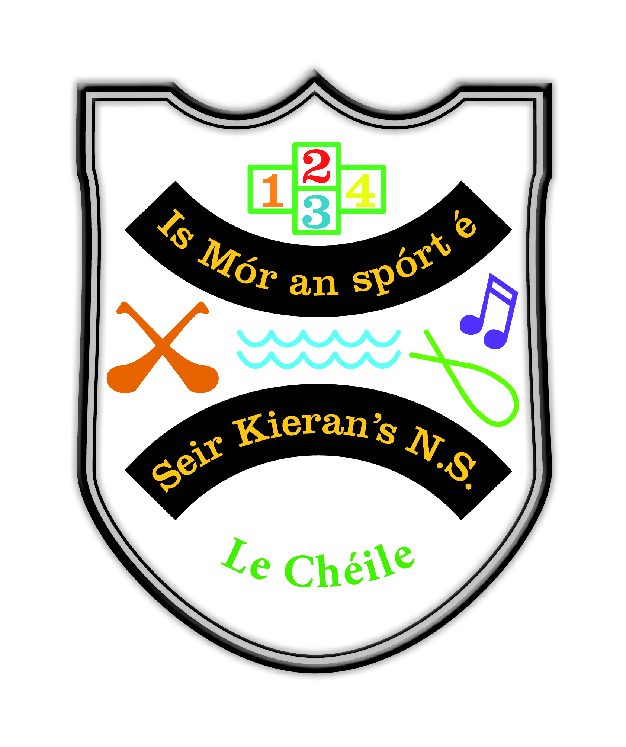

Seir Kieran’s National School

Whole School Plan for Physical Education

1. PE Framework

A full review of the PE Policy of Seir Kieran’s NS was carried out by the staff of Seir Kieran’s NS in March 2022.
The policy was presented at a Board of Management meeting on the 23rd of May 2022 and was signed off on at this meeting.

Introductory Statement:

The original policy was formulated following a consultative process which took place over a period of months. Teachers, board members and parents were involved in the process. The policy has been reviewed at various stages since, to take into account best up to date practice and advice in the area.

Rationale:
In our school we see the physical experiences of PE as an integral part of the education process without which the education of the child is incomplete. Through a diverse range of experiences providing regular challenging physical activity we aim to foster the balanced harmonious physical, social, emotional and academic development of the children in our school.

This policy was devised:
- To benefit teaching and learning in our school
- To conform to principles outlined in the primary curriculum
.
Vision:
We seek to assist the children in our school in achieving their potential through providing a balanced programme of activities where each child is encouraged to participate at his/her individual level. While we teach a broad and balanced curriculum, we are also supported by a strong tradition of inter-school competitions in hurling, camogie, football, soccer and running.

Aims
The aims of the Physical Education curriculum are:
- to promote the physical, social, emotional and intellectual development of the child
- to develop positive personal qualities
- to help in the acquisition of an appropriate range of movement skills in a variety of contexts
- to promote understanding and knowledge of the various aspects of movement
- to develop an appreciation of movement and the use of the body as an instrument of expression and creativity
- to promote enjoyment of, and positive attitudes towards, physical activity and its contribution to lifelong health-related fitness, thus preparing the child for the active and purposeful use of leisure time.

Broad objectives
When due account is taken of intrinsic abilities and varying circumstances, the Physical Education curriculum should enable the child to:

- experience enjoyment and achievement through movement
- interact and co-operate sensitively with others, regardless of cultural or social background or special needs
- develop qualities of self-esteem, self-awareness, confidence, initiative and leadership through movement
- develop an understanding of fair play and team spirit through participation and competition
- develop positive attitudes towards participation in movement activities
- experience adventure and challenge

Physical and motor development
- develop strength, speed, endurance and flexibility through engaging in a wide variety of activities
- develop agility, alertness, control, balance and co-ordination through movement
- develop personal competence in the athletic skills of running, jumping and throwing
- perform dances with confidence and competence, including simple folk and Irish dances
- develop personal competence in a range of gymnastic movements
- develop personal competence in the games skills of sending, receiving and travelling using a variety of equipment, and to apply these skills in games situations
- apply the skills needed to live and move with confidence in the environment
- build water confidence near, in, on and under water
- develop personal competence in a variety of strokes and water agility

Knowledge and understanding
- develop an understanding and general knowledge of movement activities and derive benefit as a participant and as a spectator
- develop an understanding of travel and weight-bearing as the basis of efficient body management and control, both on the floor and using apparatus
- experience and develop an understanding of the use of space, speed, effort, direction and level in the performance of actions
- develop an understanding of the appropriate basic rules, tactics and strategies of movement activities
- observe, discuss, analyse, interpret and enjoy the performance of movement
- gather, record and interpret information on achievement in movement activities
- be inventive, make decisions, solve problems and develop autonomy through movement activities
- participate in and develop a knowledge, understanding and appreciation of cultural activities through movement
- develop an appreciation of and respect for the environment through participation in activities outdoors

Creative and aesthetic development
- use the body as a means of expression and communication, using a range and variety of stimuli
- create and perform simple dances
- create and play simple games
- develop artistic and aesthetic understanding within and through movement

Development of health-related fitness
- maintain and enhance health-related fitness through vigorous physical activity that helps to promote a healthy life-style
- understand and practise good hygiene and posture
- appreciate the benefits of relaxation and cope with challenges

Development of safety
- adopt safe practices in all physical activities.

This PE Policy will be addressed under the following headings

A. Curriculum Planning:
- Strands and strand units
- Approaches and methodologies
- Linkage and integration
- Multi-grade teaching
- Assessment and record keeping
- Children with different needs
- Equality of participation and access

B. Organisational Planning:
8. Timetable
9. Resources and ICT
10. Health and safety
11. Individual teachers’ planning and reporting
12. Staff development
13. Parental involvement
14. Community links

A. Curriculum Planning

- Strands and strand units
The Strands across the P.E. curriculum for all classes are:
- Athletics;
- Dance;
- Gymnastics;
- Games;
- Outdoor and Adventure activities
- Aquatics
Each of these strands is covered each year.
These strands are further divided into strand units:
1. Athletics – Running; Jumping; Throwing; Understanding and appreciation of athletics
2. Dance: - Exploration, creation and performance of dance; Understanding and appreciation of dance
3. Gymnastics – Movement; Understanding and appreciation of gymnastics
4. Games - Sending, receiving and travelling; Creating and playing games; Understanding and appreciation of games
5. Outdoor & Adventure Activities – Walking; Orienteering; Outdoor Challenges; Understanding and appreciation of Outdoor & Adventure Activities; Activities Outdoor challenges
6. Aquatics – Hygiene; Water safety; Entry to and exit from the water; Buoyancy and propulsion; Stroke development; Water-based ball games; Understanding and appreciation of aquatics

The strands/strand units/content objectives for the relevant class level(s) are found on the following pages:
Refer to Curriculum or webpage with objectives: http://nccaplanning.ie/

- Infant classes pp. 16-23
- First and Second classes pp. 24-34
- Third and Fourth classes pp. 38-46
- Fifth and Sixth classes pp. 48-59
- Aquatics: Junior Infants-Sixth pp.62-64

Teachers choose a range of activities from all strands for each class and children have access to all six strands each year – Infant classes while engaging with the Aquatic strand, will not be visiting a swimming pool but they will get the opportunity to engage with all other strand units of the Aquatics strand.
In the case of each of these strands, where outside expertise is available from various sporting organisations and groups, it is always availed of. From time to time, the Principal in consultation with the BOM , the PA and the staff may deem it necessary to organise coaches/mentors to work alongside teachers in particular areas with the children. In such scenarios, families will never be asked to fund this, this will be funded through fundraising activities of the BOM and PA. All decisions made in this regard are made in the interests of providing children with the very best opportunities in each strand area.
As part of the Aquatics strand, children from 1st to 6th class attend Birr Swimming Pool for a six week period funded by Parents and Parent Association.
Opportunities are created to develop an understanding and appreciation of each strand unit at staff meetings.

Teachers ensure that there is continuity and progression from class to class by recording strands covered through their planning and review

Specific issues that need to be considered in multi-class situations are mixed abilities of pupils, physical strength of some pupils and group teaching.

2. Approaches and Methodologies

The teachers use a combination of teaching approaches during PE lessons. Teachers will vary the approaches according to which is most suited to achieving the objectives of the lesson, taking such factors as the content and context of the lesson into account and the needs of the learners. The teacher may move between differing approaches even within one lesson.
- Direct teaching approach
- Guided discovery approach
- Integration - e.g. with Oral Language, SESE and Art

With the aim of encouraging maximum participation in all PE activities a variety of differing methodologies are employed by the teachers through group work.
These include:
- Individual, pair, group and team play p. 51
- Station teaching pp. 51-53
- Using a play area divided into grids p. 54

3. Assessment and Record Keeping

We will assess:
- Willingness to participate in activities
- Readiness to engage with a certain activity
- The level of competence of a child in carrying out any activity
- Interest in and attitude to activity
- Willingness to cooperate in individual, pair and group activities

Our assessment tools are:
- Teacher observation
- Teacher-designed tasks

Information gained from the assessments forms part of class and school planning. Records of a child’s PE progress are recorded in end of year reports. Feedback is also shared with parents at Parent/teacher meetings in November.

4. Multi-class Teaching

Our policy is to facilitate individual, partner, team and whole class work to cater for differing levels of ability within each year group and between each class where appropriate.

Follow-up activities to a basic lesson can be introduced, where one group has an opportunity to practise again what was covered in the basic lesson, while the other group moves ahead and develops further the content of the basic lesson, for example one group bounces the ball in Gaelic while another group hops and toe-taps. Every child will experience success at their level

Group work is facilitated through the ‘station’ teaching method by organizing a group of children of similar ability or children at the same class level.

5. Children with Different Needs

It is the policy of the school to encourage and support children who find PE challenging as well as facilitating the children who have talents in this area to develop by providing them with tasks appropriate to his/her level of ability. The child with special needs shall experience the enjoyment of participation and progression through the various stages of the physical education programme according to his/her ability. All the class teachers encourage maximum participation in the Physical Education lesson by the children and provide the opportunity to benefit from a balanced PE programme for all children.

Classes are organized and activities are adapted to include children who may have physical disabilities through grouping, pairing and use of stations
Children with exceptional ability/talent for PE are encouraged and supported by offering them challenges of speed, distance and accuracy through Dribbling/Travelling activities in Games. Inactive/shy/self-conscious children are encouraged to participate in PE activities by setting realistic goals for them and allowing them to experience success at their level.

6. Equality of participation and access

- Gender issues that need to be considered in relation to the teaching of PE:
- Equal opportunities are given to boys and girls to participate in classes/activities.
- Boys/girls have equal access to and opportunities to experience all strands.
- Boys/girls have equal opportunities to enter competitions as part of extra-curricular programme.
- Class groupings are made according to ability as opposed to gender.
- The PE class is used as an opportunity to integrate the culture of all pupils.
- Provision is made for inclusion of the following: Children experiencing any form of disadvantage; Children with disabilities.
- The school has an agreed policy with regard to dispersing available funds to ensure that every child has access to and participates in all PE activities provided by the school. Parents, however, are asked to part finance the Aquatics strand as the costs associated with this are high. As is always the case with everything provided in our school, finance will never be a factor in providing children with equality of access to educational opportunities.

7. Linkage and integration
(Refer to Curriculum p. 13, 18, 37, pp.45-47 Teacher Guidelines)
- Linkage:
Linkage can take place within Physical Education, for example many playground games can be planned as part of an Athletics or Games unit; Athletics as part of Games activities; Orienteering incorporating games.

- Integration:
Integration is planned and organized by staff through planning and is regularly used in Gaeilge, Drama, SPHE and Music among other subjects.
Theme based activities are used to support integration by staff when possible. They be recorded on fortnightly plans.

- Language:
The school creates opportunities for pupils to discuss and talk about their own and others’ performance in PE during and after the PE activity e.g. “What skills did you learn?”
We enable children to develop a vocabulary for discussing and critiquing PE activities through similar discussions.

B. Organisational Planning:

8. Timetable
One hour per week (at a minimum) is allocated at each level for PE.
There is blocked time for specific strands:
A six week programme of visits to a local swimming pool to develop the Aquatics Strand for 1st – 6th class pupils.
Children wear the school tracksuit on days of PE.

The school and the parish in which it is located holds a rich tradition in the area of Gaelic games. A very strong link exists between the local GAA club and the school. The school principal in conjunction with parents’ coaches school teams outside of school time. Children are also coached during break times and lunch times. On occasion discretionary time within the school day is also allotted to the promotion of physical activity within the context of hurling, camogie and football.
Seir Kieran’s NS believes that hurling and camogie hold a special place within the lives of the children and the parents of Seir Kieran’s NS. For this reason hurling and camogie are promoted in such a manner to promote the maximum physical activity amongst the children of our school.

9. Code of ethics
(Refer to school’s Child Protection Policy based on the Department of Education and Science guidelines accompanying the ‘Children First’ guidelines.
Coaches, tutors and life guards are used to support the class teacher in the implementation of some aspects of the PE curriculum strands in the school.
All outside instructors follow a code of ethics with regard to coaching and are made fully aware of the school’s Child Safeguarding Statement, Risk Assessment and all that is expected from them on a Child Protection level.

10. After school activities and wider community involvement
The school provides further opportunities within an extra-curricular programme through Cumann na mBunscol for camogie, hurling, football and handball.
We ensure that these extra-curricular activities are linked to the PE programme by focusing on participation, skills development and enjoyment.
Seir Kieran’s NS enters Cumann na mBunscol hurling, camogie, footballl and INTO skills competitions annually. The school organises a Sports Day where parents/community/others can be invited to view and assist in children’s PE activities. As has been previously stated, the school enjoys a very positive relationship with the local GAA club and the club fully supports the school in resourcing it to help all children take part in fundamental movement skills programmes which are beneficial to the children in all strand areas. While the club and community seek to promote GAA, they are very respectful of the fact that coaching which they provide has to extend into other strands of the PE curriculum and that ‘Games’ is only one strand within the PE curriculum.

11. PE equipment and ICT
The school carries out an annual inventory of it’s PE resources and the principal ensures that the PE equipment is sourced and got when required. The equipment is appropriate for the PE curriculum.
The equipment is stored safely and available to all teachers. (Bottom of GP room)
The equipment is purchased centrally by the principal.
Additional materials needed are: new basketballs, a pump

ICT (Refer to p. 101 Teacher Guidelines)
ICT is used in PE for Treasure hunts, orienteering and advertising an event, photographing activities, Music CDs, Healthy lifestyle DVDs.
ICT is also used to record PE activities and to reflect on what can be learned from these recordings.
Appropriate software currently available in the school includes chrome books ipads and Digital cameras.

12. Health and safety
(Refer to school’s Health & Safety Policy)
One member of staff has first aid training.
Staff members are aware that certain children have specific medical conditions.

13. Individual teachers’ planning and reporting
- The school has a plan to address setting out the months in which strands can be addressed. This plan is flexible and allows for the fact that it may not be possible to teach a particular strand in a particular month so the option is there to teach another strand. Please refer to Appendix A at the end of this policy.
- Teachers plan using the strands and strand units. Where possible, a thematic approach is used. (Refer to pp. 34-35 Teacher Guidelines)
- The school principal consults with the school staff with regard to the availability of PE equipment

14. Staff development
- Teachers have access to current research, reference books, resource materials, and websites dealing with PE. The principal will take responsibility for monitoring developments.
- School personnel can research new methodologies and arrange for demonstrations or opportunities to try out equipment/resources and assess whether or not they should be purchased.
- Teachers are encouraged to attend any courses available pertaining to PE.
- They are encouraged to share the expertise acquired at these courses at staff meetings.
- Time is allocated at staff meetings to discuss aspects of the PE curriculum when the need arises.
- Teachers can avail of internal and/or external expertise to inform and upskill the school community in these areas.

15. Parental involvement
(Refer to Primary School Curriculum, Your child’s learning, Guidelines for Parents)
- Parents will be involved in supporting the PE plan. Parents assist with Swimming attendance and are welcome to assist in coaching.
- The PE plan will be communicated to parents through the PA and is available on the school website.
- Parents can support the child in fostering interest in PE by not putting undue pressure on children to always win and stressing participation, enjoyment and skill development on their child.
- Parents are invited to view the children’s achievements in PE via Sports Day and participate in PE day.
- Special events are held, e.g. Sports for All Day.

16. Community links
- The local GAA club is fully supportive of GAA activities in the school and provides its facilities and equipment for the school’s use. As has been stated the school takes great pride in this relationship and for this reason GAA is at the heart of our PE activities.

C. Success criteria
This plan will make a difference to the teaching and learning of PE in our school. The criteria that will indicate success includes answering the following questions:

- How will we know that the plan has been implemented?
- Teachers’ preparation based on this plan
- Procedures outlined in this plan consistently followed

- Has the plan achieved its aims? What are the indicators? (Refer to Aims)
Means of assessing the outcomes of the plan include
- Teacher/parent/community feedback
- Children’s feedback regarding the activity level, enjoyment and skill development of the classes.
- Inspectors’ suggestions/report
- Second level feedback

- Has the plan promoted the key considerations when implementing a programme of Physical Education?
- The importance of enjoyment and play
- Maximum participation by all children
- The development of skills and understanding
- A balance between competitive and non-competitive activities
- A balance between contact and non-contact activities
- Providing opportunities for achievement for each child
- Providing activities equally suitable for girls and boys.

Review
It will be the responsibility of the Principal Teacher to co-ordinate a review of this policy.
This policy will be implemented fully once ratified by the Board of Management. This policy will be reviewed in March 2024 and every second year thereafter. This policy was ratified by the BOM on the 23/5/2022

This policy was ratified at a Board of Management meeting on the 23rd of May 2022. It will be reviewed in 2024.

Signed;

John Kirwan.
Chairperson of the Board of Management.

Appendix 1

The following is a plan setting out when strands will be taught, throughout the school year.

September: Athletics/Games
October: Athletics/Games
November: Athletics/ Dance
December: Dance/Games
January: Aquatics/Dance
February: Aquatics/Games
March: Gymnastics/Games
April: Gymnastics/Athletics
May: Gymnastics/Outdoor & Adventure Activities
June: Outdoor & Adventure Activities/ Games

The plan provides for the option of two strands to be taught each month. One of the two strands may only be taught in the month but the availability of two strands provides the teachers with a fall back to teach another strand should it not be possible to teach a particular strand in a particular month. Also Infants will not be attending swimming lessons so the teacher here has added flexibility to teach from other strand areas in the months that Aquatics is planned.

