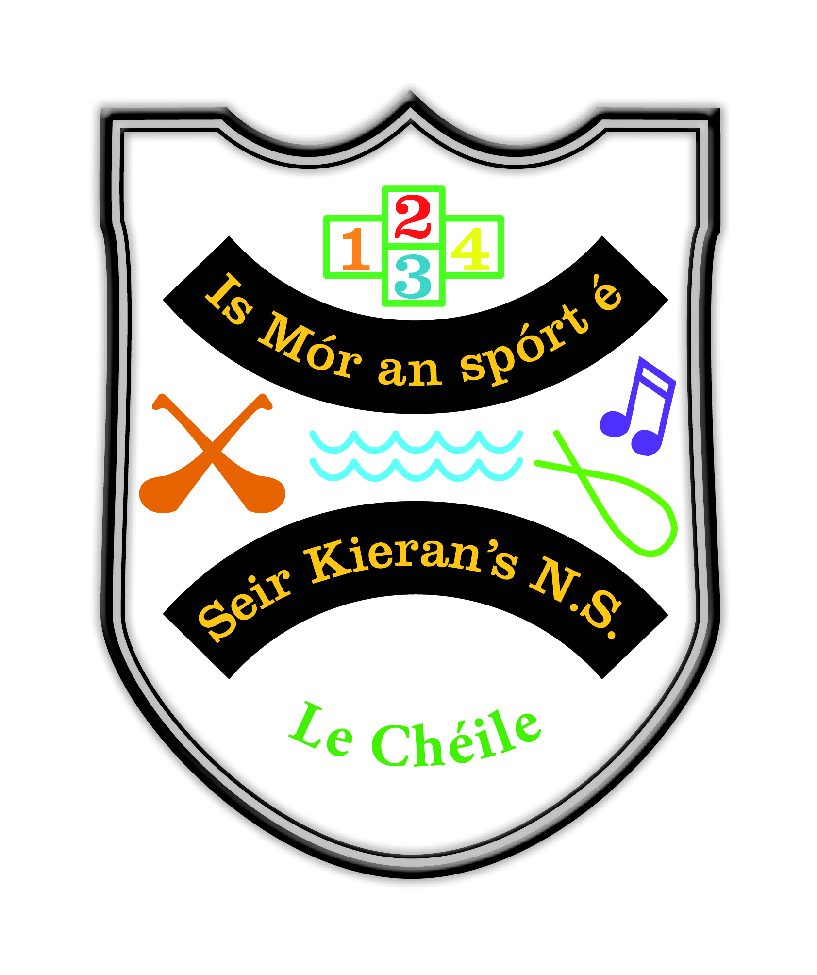

Seir Kieran’s NS

Le Chéile Enrolment Application Form For September 2024

Pupil’s First Name: _________________ Surname: ___________________________

Date of Birth: _____________________ Gender: ____________________________

Address (at which the applicant resides): _____________________________________________________________________

______________________________________________ Eircode:________________

Name and class of Sibling(s) currently enrolled:

_____________________________________________________________________

_____________________________________________________________________

Parish in which the applicant resides: ______________________________________

Does your child have an up to date educational psychological assessment confirming a diagnosis of ASD: Yes No

Does your child have a written professional recommendation to attend an ASD class in a mainstream setting: Yes No

Please enclose reports regarding the above.

Parent(s)/Guardian(s) Details:

Name: ___________________________ Name: _____________________________
[ ] Parent [ ] Custodian [ ] Legal Guardian [ ] Parent [ ] Custodian [ ] Legal Guardian

Address:_________________________ Address: ____________________________

________________________________ ____________________________________

Home Tel._______ Mobile ___________ Home Tel.________ Mobile _____________

Email. __________________________ Email. ______________________________

Signature 1: _____________________ Signature 2: ________________________

Date: ___________________________ Date: ______________________________

This form must be returned to Seir Kieran’s NS, Clareen, Birr, Co. Offaly Eircode R42 KA97 on or before 23/02/2024.

