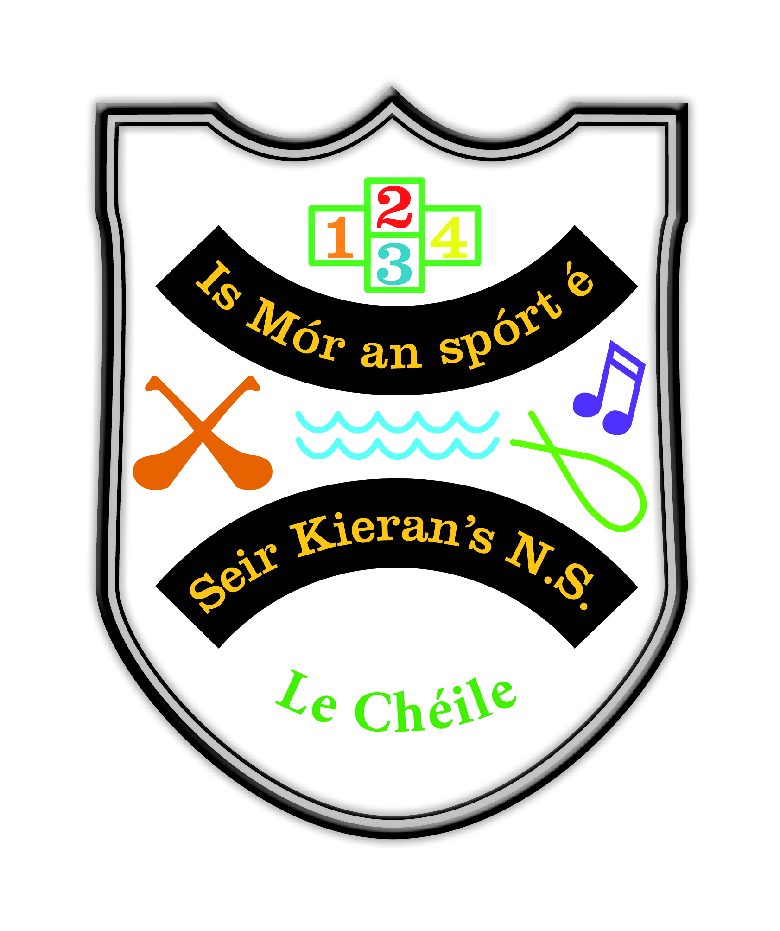

Behaviour and Discipline

This policy was reviewed by teachers, parents and Board of Management of Seir Kieran’s N.S. in November 2022. The Parents Association and the children were also consulted and advised on the contents of the policy. The policy was then ratified by the board in November 2022.

The aims of primary education may be stated as

- To enable the child to live a full life as a child
- To equip him/herself of further education so that he/she may go on to live a full and useful life as an adult in society.
The teachers and staff are committed to the realisation of these aims. The Board of Management of the school is committed similarly. Parents of children in this school have been strongly supportive of these aims for many years.
The ethos of our school is a major factor in establishing and maintaining high standards of behaviour and discipline. This means a strong sense of community within our school and a high level of co-operation among teaching staff and between staff, pupils, parents Board of Management and ancillary staff.
In devising the code, consideration has been given to the particular needs and circumstances of this school. The aim is to ensure that the individuality of each child is accommodated while acknowledging the right of each child to education in a relatively disruptive free environment.

The Code of Discipline aims to achieve:

- The efficient operation of the school
- The structuring of in-class discipline, which prompts an efficient, and stimulating environment.
- The maintenance of good order and safety throughout the school day, including break times, sports activities and all movements between classes.
- The development of self-discipline in all pupils and care and courtesy towards others.
- The development of respect for school buildings, all school property and the general school environment.
Principles of our Discipline Policy.
Our Policy is based on the principles of caring, fairness, respect, tolerance, compassion, and courtesy. The attitude of the teaching staff will have a critical bearing on how successful the policy is likely to be.
Staff shall consider themselves responsible at all times for the behaviour of children within sight or sound of them and shall respond promptly and firmly to any incident of unacceptable behaviour.
If our school is to achieve a happy, secure environment where the children can develop and learn to their full potential, then a positive, friendly, caring and encouraging atmosphere will provide a framework which promotes constructive behaviour and discourages unacceptable behaviour. Therefore, every effort will be made by all members and teaching staff to adopt a positive approach to the question of behaviour in the school.
The school places greater emphasis on rewards than on sanctions.
The agreed code offers a framework within which positive techniques of motivation and encouragement are utilised by teachers.
The school recognises the variety of differences that exist between children and the need to accommodate these differences.
General standards of behaviour and conduct expected by the school;

Respect and Courtesy: Pupils are expected to behave in a responsible manner both to themselves and all others. They are expected to treat all other pupils, all members of staff and visitors to the school with respect and courtesy at all times. The use of any form of vulgarity or offensive language is unacceptable.
Punctuality: Pupils must be in on time for school each day and return to class punctually after breaks. The official opening time of the school is 8.55am. Classes for Infants end at l.35pm. All other classes end at 2.35pm. No responsibility is accepted for pupils outside of these times. Those collecting children from school should always be punctual. Lateness causes great anxiety especially for young children.
Safety when entering or leaving the school: Children must enter and exit from the school only via the gate. Children must walk when entering or leaving school. Parents must leave space for teachers to park cars and room for pupils to walk by the railing to the school gate. Courtesy and respect must be shown to the school bus driver and school bus escort. Pupils must walk when coming from the bus in the morning and when going towards it in the evening. Pupils must remain seated when on the bus and behave in an orderly safe manner. Pupils will be escorted to and from the bus by school staff.
Attendances/Absences: Every absence of a child from school must be accounted for either by parents/guardians forwarding a written note. If a child has to leave school early or be absent from school for part of the day, a written note/an email must be forwarded to the class teacher in school and the child must be picked up by an adult from the classroom. This is to ensure as far as possible, the safety of children throughout school hours.
Illness: Any infectious illness should be notified to the school immediately. Children should return to school only when fully recovered.
Personal Property: Children must have their names on their coats and on all personal property such as school books, copies etc.
School Property: Pupils must respect all school property and treat all schoolbooks and equipment with care. Parents will be held accountable for the cleaning, repair or replacement of any school property or equipment wilfully damaged or vandalised by their children.
School environment: Pupils must keep the school environment clean and litter free. Pupils are expected to co-operate fully in any organised clean up activities.
Behaviour in Class.
Pupils must have all books and materials or equipment required.
All pupils are expected to work to the best of their ability. Written work must be presented neatly.
Respect and courtesy are basic to classroom behaviour. Disrespectful behaviour towards other pupils, towards a teacher, a member of staff or towards any visitors to the school is unacceptable.
Pupils must respect the right of other pupils to learn. Any behaviour that interferes with this right, e.g. regular disruption of the class or persistent disturbance of others is unacceptable behaviour. Pupils are expected to co-operate fully with their teachers’ instructions as given so that an effective education programme can be undertaken.
Uniform
Pupils are expected to wear the correct uniform each day.
Behaviour out of Class.
Pupils should treat others as they would wish to be treated themselves. Pupils should behave in an orderly manner at all times and must walk when going from one area to another within the school buildings or in the school yard area. This is to ensure the safety of themselves and all others.
Pupils must not behave in any way, which endangers others or themselves. Examples of behaviour which endangers are: roughness, fighting, kicking, striking, spitting, punching, tripping or verbal abuse. Teachers will seek to ensure that standards of safety are observed and shall prohibit games or activities considered to be dangerous. Any directions given by teachers on these matters are to be followed implicitly. Pupils are required to play only in the designated yard area. All pupils are required to line up promptly and in an orderly manner at the end of breaks.
Lining up: Children are expected to always line up in an orderly manner in their groupings in the morning, at break/lunch times and in the evening. They are also expected to proceed to classrooms/the playground/the school in an orderly fashion.
Inclement Weather: On such days children stay in their classrooms for break, teachers may provide the children with activities they can engage in or put a film on for them to view. The teacher on duty will supervise, keeping doors open and moving from doorway to doorway within the hall area. Where an SNA is available, he/she will also assist with supervision.
Behaviour in School Field/Playing Pitches. Respect and consideration for others are the basics. Any form of verbal or physical abuse of others is unacceptable and is considered to be serious misbehaviour. Pupils are required to use the areas assigned to their particular class level.
Bullying and Intimidation of others .This is always regarded as a serious offence. All forms of threatening behaviour are unacceptable. Children must be able to attend school and to go home safely and without fears.
If children are being bullied or threatened either verbally or physically, teachers must be told so that the matter can be dealt with effectively. If teachers are not informed, then they cannot be held responsible.
Rewards for Acceptable Behaviour.
The following are some of the ways of showing appreciation for acceptable good behaviour, which are in operation in the school. Oral praise, written praise, pupil to be given job, responsibilities that they like, teacher communication with parents, pupils to be given small prizes, merit lists, merit stars, reduction of homework.
Assembly.
An assembly is held each Friday morning in the school. Good behaviour is affirmed at assembly time. As a whole school children are regularly reminded of the behaviour which is expected from them. The positive effects of this good behaviour is also explained. Children are also provided with examples of behaviour which are seen as unacceptable and again the reasons for this behaviour falling into the category of ‘unacceptable’ are also explained.

Misbehaviour is categorised into 3 levels – ‘Minor misbehaviour’, ‘Major Misbehaviour’ and ‘Gross Misbehaviour’. Please see the tables which follow as they will define what fall within the definition of specific levels of misbehaviour, as well as setting out the actions and sanctions which can follow as a result of such misbehaviour.

 | Level 1: Minor Misbehaviour | Actions | Sanctions
•  •  •  •  •  •  •  •  •  •  •  •  •  •  •  •  •  • | Persistently answering out in class  Disrupting the learning/play of others  Deliberately disobeying or not responding to the teacher or adult in charge Once off name calling  Leaving the classroom or yard without permission  Taking others’ belongings without permission  Incomplete homework without parental explanation  Uncooperative behaviour/Negative attitude/Insolence  Bad language  Back answering  Playing outside assigned areas in the yard Ignoring bells and not lining up.  Being unseated before school starts/break times on wet days  Chewing gum  Isolation of others  Discarding uneaten lunch in the bin  Swinging on chairs  Non-compliance with uniform code  Littering the school environment  Rough Play | - Class Contract  - Regular referring to rules in class, yard and at assembly  - Verbal Reasoning  - Increasing awareness of appropriate behaviour  - Possibly informing parent of  child’s misbehaviour  - Time out in the shed in the yard  - Send to time out space in the shed for a prescribed time. 1/3/5 minutes depending on age. | - Moving child to another place in class  - Moving child to another class to complete ‘Thinking about my Behaviour’  (signed by parents)  - Loss of privilege  - Extra homework  - Completing  ‘Thinking about my  Behaviour’ (signed by parent) following time in the Time Out Space.  - If pupil disturbs during time out, increase T.O. by 1/3/5 minutes.  - Time out in the shed in the yard

 | Level 2: Major Misbehaviour | Actions | Sanctions
• | Bullying
•  •  •  •  •  •  •  •  •  •  •  •  •  •  •  •  •  • | Defiance when given an instruction  Damaging other people’s property  Deliberate disrespect towards school staff  Leaving the school building without permission Aggressive/disrespectful/racist/homophobic inappropriate behaviour or language towards children and others.  Any form of harassment or discrimination  Physical fighting/aggression or deliberately hurting another  Persistent name calling/intimidating/threatening  behaviour to school community Theft in the school environment  Lying  Having a mobile phone in school  Misuse of the internet  Posting on social media about others without their consent  Persistent isolation/victimisation of another child  Refusing to complete work  Lewd drawings  Graffiti on school books or property  Repeated instances of Level 1 behaviour | - Changing the classroom seating arrangements.  - Principal speaks to the class  - Behaviour Intervention  - Plan/Student Support Card identifying targets.  - Meeting with parents/principal  - Remove mobile phone device from student when found  - Inform B.O.M. in the case of reported bullying incidents | - Any of the level 1 sanctions  - Contact relevant professional services  - Yard detention  - Suspension  - Parent must collect mobile phone device from the teacher.

Level 3: Gross Misbehaviour | Actions | Sanctions
- Repeated or serious instances of Level2 behaviour which have not been modified by intervention.  - Bringing dangerous objects to school  - Deliberately injuring/damaging another pupil/staff member or property  - Behaviour which is a serious threat to the learning or safety of others  - Endangering self, other pupils and/or staff  - Deliberate damage to property  - Physical or verbal aggression towards staff  - Leaving the school grounds without permission  - Use of a mobile phone on school premises  - Bringing illegal/toxic substances onto the school premises  - Presenting at school under the influence of illegal substances  - Truancy  Any behaviour which extends the boundaries of those listed above may be brought to the attention of the Board of Management.  The Board of Management has the discretion to decide on an appropriate sanction. | - Remove child from class  - Inform Principal  - Inform Parents  - Where there is a victim as a result of misbehaviour, see that the victim receives all support which is necessary.  - Report to B.O.M.  - Report to be completed by class teacher and principal. | - Any Level 1 or 2 sanctions  - Suspension (work assigned including completing Individual Report  Form)  - Meeting after suspension to  reflect on behaviour  - Contact relevant professional services  - Expulsion: Repeated  incidents of Level 3 behaviour can result in a pupil being expelled.
In the case of gross misbehaviour, the Board shall authorise the Chairperson or Principal to sanction an immediate suspension, pending a discussion of the matter with the parents. Expulsion may be considered in an extreme case, in accordance with Rule 130 (6).

PROCEDURES FOR SUSPENSIONS & EXPULSIONS

Suspension Definition of Suspension:
‘Requiring the student to absent himself/herself from the school for a specified, limited period of school days’
Developing A Code of Behaviour: Guidelines for Schools, NEWB Developing A Code of Behaviour: Guidelines for Schools, National Educational Welfare Board

Authority to Suspend: The Board of Management of Seir Kieran’s National School has formally delegated the authority to impose an ‘Immediate Suspension’ to the Principal Teacher. An ‘Immediate Suspension’ may be for a period of one to three school days depending on the severity of the specific behaviour, in exceptional circumstances and with the approval of the Chairperson of the Board, the suspension may be for a longer period but in any event will not exceed 5 school days. Furthermore, the Board of Management has formally delegated to the Principal Teacher the authority to impose an ‘Automatic Suspension’ for named behaviours detailed in this policy. An Automatic Suspension may be for a period of one to three school days depending on the severity of the specific behaviour. In exceptional circumstances and with the approval of the Chairperson of the Board the suspension may be for a longer period but in any event will not exceed 5 school days. The Board retains it’s authority to suspend a student in all other cases/circumstances.

Immediate Suspension and Automatic Suspension;
An ‘Immediate Suspension’ will be deemed to be necessary when the Principal reaches the determination that the continued presence of the pupil in the school at the time would represent a serious threat to the safety and wellbeing of pupils or staff of the school. An ‘Immediate Suspension’ may be for a period of one to three school days depending on the severity of the specific behaviour. In exceptional circumstances and with the approval of the Chairperson of the Board the suspension may be for a longer period but in any event will not exceed 5 school days.

An ‘Automatic Suspension’ is a suspension imposed for named behaviours. The Board of Management of Seir Kieran’s National School, having given due consideration to it’s duty of care as prescribed by Health & Safety Legislation, has determined that the following named behaviours will incur ‘Automatic Suspension’ as a sanction;
- Physical assault/violence towards a pupil or member of staff
- Physical violence resulting in serious damage to school property
- Threatening or abusive behaviour (including verbal abuse) towards a member of staff
- Running away from school during school contact time without parental consent

An Automatic Suspension may be for a period of one to three school days depending on the severity of the specific behaviour, in exceptional circumstances and with the approval of the Chairperson of the Board the suspension may be for a longer period but in any event will not exceed 5 school days.
Parent(s)/Guardian(s) will be informed of an Immediate or Automatic Suspension by telephone, and arrangements will be made with them for the pupil to be collected. In no circumstance will a student be sent home from school prior to his/her parent(s)/guardian(s) being notified.
Formal written notification of the suspension will issue in due course, but no later than 2 school days after the imposition of the suspension. Such a notification will detail:
- the duration of the suspension and the dates on which the suspension will begin and end
- the reasons for the suspension
- any study programme to be followed
- the arrangements for returning to school, including any commitments to be entered into by the pupil and the parent(s)/guardian(s).

The Board of Management acknowledges that the decision to impose either an Immediate or Automatic Suspension does not remove the duty to follow due process and fair procedures. In this regard, and following a formal investigation, to be completed no later than 2 school days after the incident, the Board will invite the pupil and his/her parent(s)/guardian(s) to a meeting with the Principal, Deputy Principal and Chairperson of the Board ( or other Patron Rep.) to discuss
- the circumstances surrounding the suspension
- Interventions to prevent a reoccurrence of such misconduct.

The Board of Management of Seir Kieran’s National School acknowledges the fundamental importance of impartiality in the investigation process. In this regard the following undertaking is given;
- No person with a vested interest or personal involvement in the matter will be involved in the organisation or implementation of the investigation procedure.

Procedures in Respect of Other Suspensions: In cases other than those of Immediate or Automatic Suspension the following procedures will apply; Where a preliminary assessment of the facts confirms serious misbehaviour that could warrant suspension, the Principal will initiate a formal investigation of the matter. The Principal, Deputy Principal and Chairperson of the Board (or other Patron Rep.) will investigate. The following procedures will be observed;
- A written letter containing the following information will issue to Parent(s)/guardian(s); details of the alleged misbehaviour, details of the impending investigation process, and notification that the allegation could result in suspension.
- An invitation to a meeting, to be scheduled no later than 5 school days from the date of the letter, where parent(s)/guardian(s) are provided with an opportunity to respond before a decision is made or a sanction imposed.

The Board of Management of Seir Kieran’s National School acknowledges the fundamental importance of impartiality in the investigation and decision-making process. In this regard the following undertakings are given;
- The person(s) involved in the investigation process will on presentation of a full report of the facts absent himself/herself/themselves from the decision-making process
- Where the Principal, Deputy Principal and Patron Rep. recommend a suspension, the Board of Management will hold a meeting to authorise the decision and where necessary to determine the length of suspension. Where a decision to suspend has been made, the Chairperson of the Board of Management will provide written notification to the parent(s)/guardian(s) and the pupil of the decision.
The letter will confirm:
- the duration of the suspension and the dates on which the suspension will begin and end
- the reasons for the suspension
- any study programme to be followed
- the arrangements for returning to school, including any commitments to be entered into by the pupil and the parent(s)/guardian(s)
- the provision for an appeal to the Board of Management.
Where a suspension brings the total number of days for which the pupil has been suspended in the current school year to twenty days, the parent(s)/guardian(s) will be informed of their right to appeal to the Secretary General of the Department of Education and Science under Section 29 or the Education Act 1998 and will be provided with information on the submission of such an appeal.

Expulsion Definition of Expulsion:
‘A student is expelled from a school when a Board of Management makes a decision to permanently exclude him or her from the school, having complied with the provisions of section 24 of the Education (Welfare) Act 2000.’ Developing A Code of Behaviour: Guidelines for Schools, National Educational Welfare Board

Authority to Suspend: The authority to expel a pupil is reserved by the Board of Management.
Procedures in Respect of Expulsion: Where a preliminary assessment of the facts confirms serious misbehaviour that could warrant expulsion the following procedures will apply:
- A detailed investigation will be carried out under the direction of the Principal (or a Nominee of the Board if required) As part of the investigation a written letter containing the following information will issue to parent(s)/guardian(s) details of the alleged misbehaviour, details of the impending investigation process, and notification that the allegation could result in expulsion.
- An invitation to a meeting, to be scheduled no later than 5 school days from the date of the letter, where parent(s)/guardian(s) are provided with an opportunity to respond
- The Principal (or BoM Nominee) will make a recommendation to the Board of Management. Where the Principal (or nominee) forms a view, based on the investigation of the alleged misbehaviour, that expulsion may be warranted, the Principal (or nominee) makes a recommendation to the Board of Management to consider expulsion. In this event the Principal (or nominee) will:
- inform the parent(s)/guardian(s) that the Board of Management is being asked to consider expulsion
- ensure that parent(s)/guardians have records of: the allegations against the student; the investigation; and written notice of the grounds on which the Board of Management is being asked to consider expulsion
- provide the Board of Management with the same comprehensive records as are given to parent(s)/guardian(s)

Consideration by the Board of Management of the Principal’s (or BOM’s Nominee) Recommendations & the Holding of a Hearing
If, having considered the Principal’s report, the Board of Management decides to consider expelling a student, a hearing will be scheduled. The parent(s)/guardian(s) will be notified in writing
- as to the date, location and time of the hearing
- of their right to make a written and oral submission to the Board of Management
- that they may if they so choose be accompanied at the hearing

The Board of Management undertakes that the timing of such written notification will ensure that parent(s)/guardian(s) have enough notice to allow them to prepare for the hearing. In respect of the expulsion hearing the Board gives an undertaking that;

- the meeting will be properly conducted in accordance with Board procedures
- the principal (or BoM nominee) and parent(s)/guardian(s) will present their case to the Board in each other’s presence
- each party will be given the opportunity to directly question the evidence of the other party
- the parent(s)/guardian(s) may make a case for a lesser sanction if they so choose

Board of Management Deliberations & Actions following the Hearing
Where the Board of Management, having considered all the facts of the case, is of the opinion that the pupil should be expelled, the Board
- Will notify the Educational Welfare Officer in writing by registered post of it’s opinion, and the reasons for this opinion.
- Will not expel the student before the passage of 20 school days from the date on which the Educational Welfare Officer receives this written notification
- Will in writing notify the parent(s)/guardian(s) of their decision and inform them that the Educational Welfare Officer is being contacted
- Will be represented at the consultation to be organized by the Educational Welfare Officer
- Will suspend the student, if it is deemed likely that the continued presence of the student during this time will seriously disrupt the learning of others, or represent a threat to the safety of other pupils or staff.

Confirmation of the Decision to Expel
Where the twenty-day period following notification to the Educational Welfare Officer has elapsed, and where the Board of Management remains of the view that the student should be expelled, the Board of Management will formally confirm the decision to expel. Parent(s)/guardian(s) will be notified in writing that the expulsion will now proceed. They will also be informed of their right to appeal to the Secretary General of the Department of Education and Science under Section 29 or the Education Act 1998 and will be provided with information on the submission of such an appeal.
The Board of Management of Seir Kieran’s National School acknowledges the fundamental importance of impartiality in the investigation and decision-making process. In this regard the following undertakings are given;
- No person with a vested interest or personal involvement in the matter will be involved in the organisation or implementation of the investigation procedure, nor will such a person be involved in the decision-making process.
- The person(s) involved in the investigation process will on presentation of a full report of the facts absent himself/herself/themselves from the decision-making process.

Removal of Suspension (Reinstatement)
Following or during a period of suspension, the parent/s may apply to have the pupil reinstated to the school. The parent/s must give a satisfactory undertaking that a suspended pupil will behave in accordance with the school code and the Principal must be satisfied that the pupil’s reinstatement will not constitute a risk to the pupil’s own safety or that of the other pupils or staff. The Principal will facilitate the preparation of a behaviour plan for the pupil if required and will readmit the pupil formally to the class

Children with Special Needs
All children are required to comply with the code of behaviour. However, the school recognises that children with special needs may require assistance in understanding certain rules. Specialised behaviour plans will be put in place in consultation with parents and the class teacher, SET, and or principal will work closely with home to ensure that optimal support is given. Cognitive development will be taken into account at all times. Professional advice from psychological assessments will be invaluable. The children in the class or school may be taught strategies to assist a pupil with special needs adhere to the rules and thus provide peer support. This will be done in a supportive and safe way, acknowledging and respecting the difference in all individuals.
Every effort will be made to have an emotionally disturbed child referred for psychological assessment without delay. Help will be sought also from support services within the wider community e.g. Community Care Services provided by Health Boards.

Communicating with Parents
Communicating with parents is central to maintaining a positive approach to dealing with children. Parents and teachers should develop a joint strategy to address specific difficulties, in addition to sharing a broader philosophy which can be implemented at home and in school. A high level of co-operation and open communication is seen as an important factor encouraging positive behaviour in the school. Structures and channels designed to maintain a high level of communication among staff and between staff, pupils and parents have been established and are being reviewed regularly. Parents are encouraged to talk in confidence to teachers about any significant developments in a child’s life (in the past or present), which may affect the child’s behaviour.
The following methods of communication are to be used within the school:
- Informal/formal parent/teacher
- Through children’s homework journal (infants do not have a homework journal, please check bags for notes)
- Letters/notes from school to home and from home to school
- School notice board
- Newsletters/school web-site/e-mails
- Text a Parent service.

It is a condition of attendance of the school that pupils abide by the Rules and Regulations of this Code of Behaviour/Discipline

Ratification & Communication; This policy was ratified at a Board of Management meeting on the 21st of November. The policy will be fully reviewed again in 2025.
A copy of this Code of Behaviour/Discipline is available to all parents. This can be viewed on our school website.

