Seir Kieran’s NS

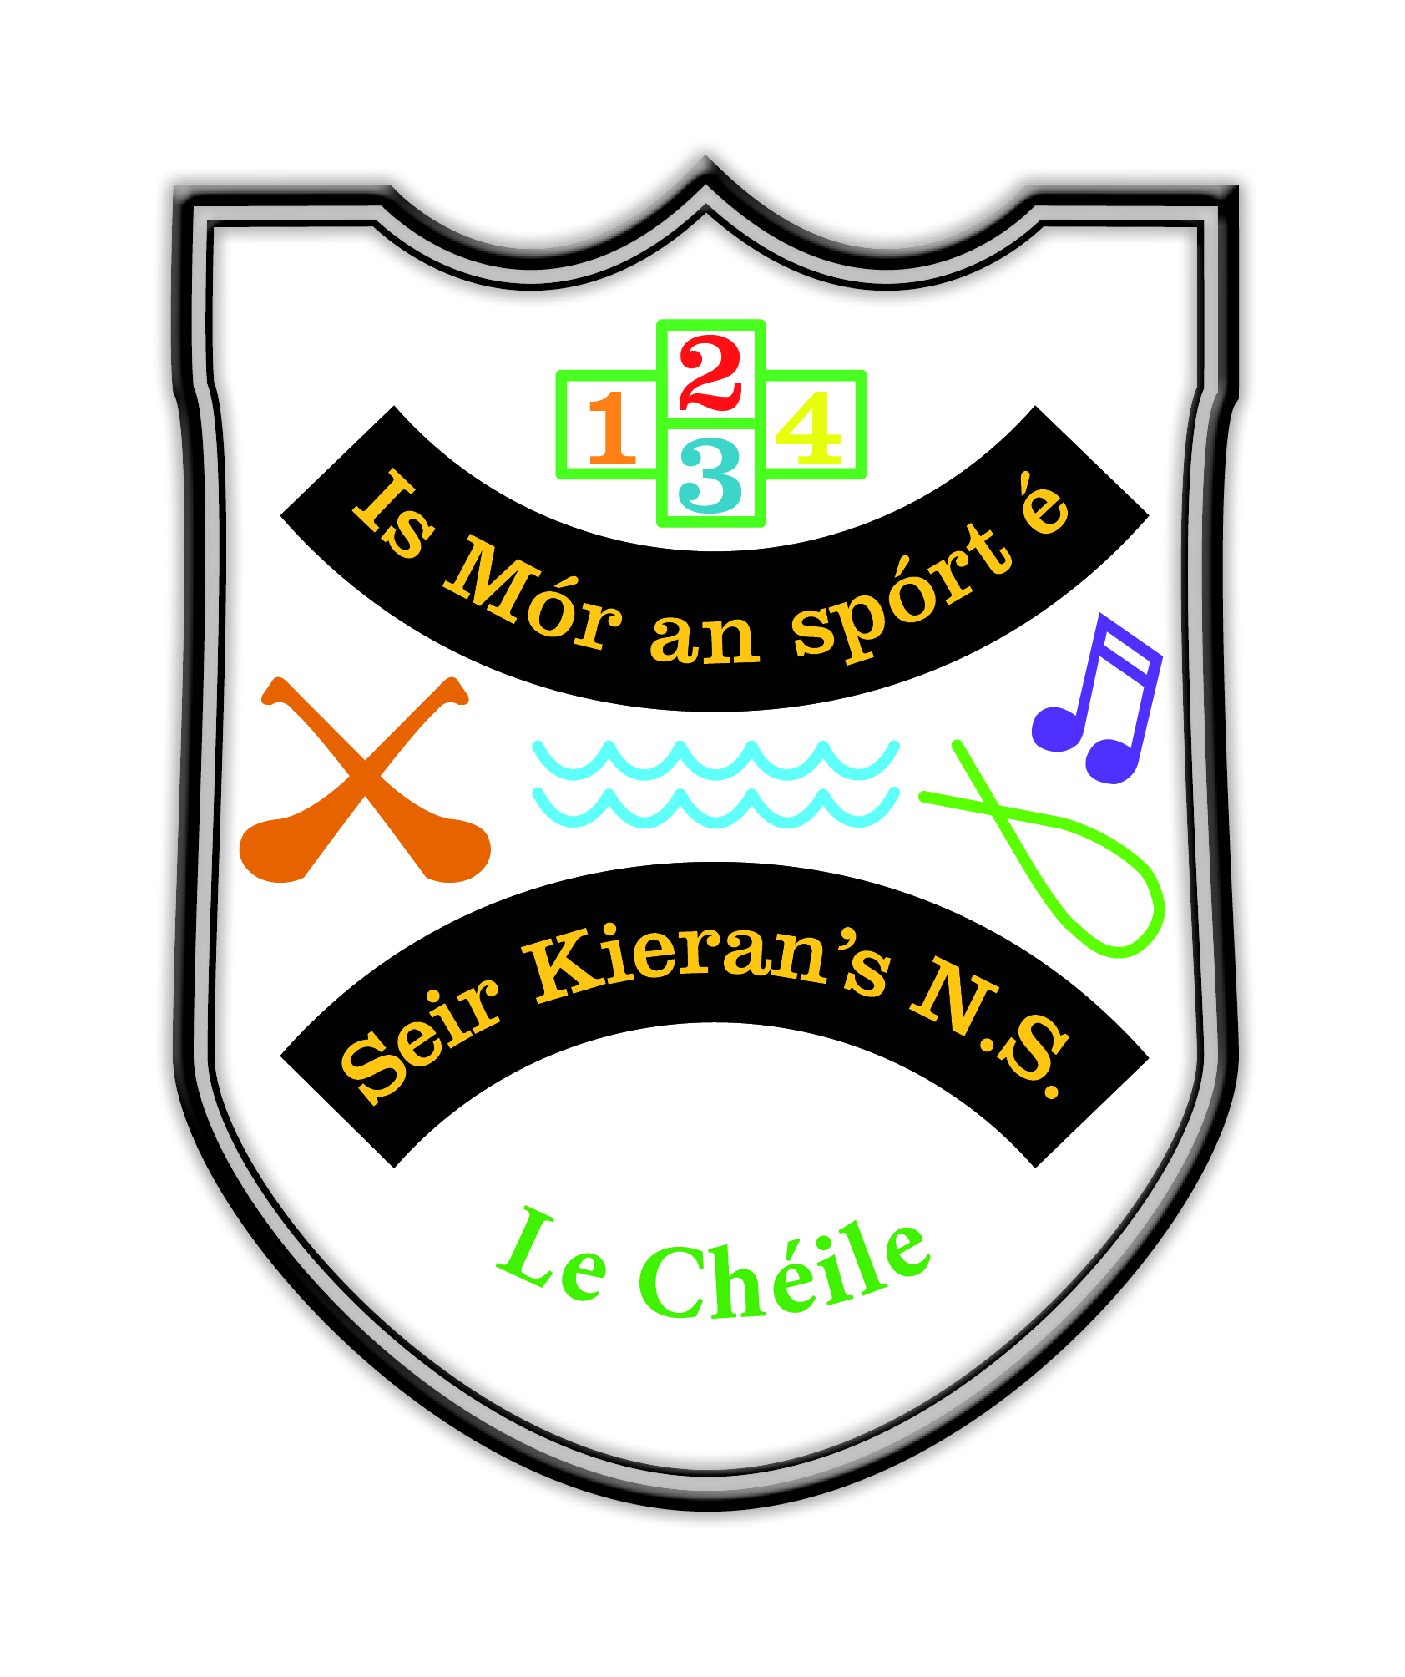

Assessment Policy

Reviewed in Term 1 2022

_______________________________________________________________

Table of Contents

- Introductory Statement and Rationale
- Relationship to Characteristic Spirit of the School
- Aims of our Assessment Policy
- Purposes of Assessment
- Definition of Assessment
- Range of Assessment Methods used
- Assessment for Learning
- Assessment of Learning
- Recording and Storing the Results of Assessments
- Assessment Folder
- Success Criteria
- Roles and Responsibilities
- Timetable for Review
- Communication
- Ratification

Assessment Policy 2022

Introductory Statement and Rationale
This original policy was formulated by the staff Seir Kieran’s NS. The policy is based on advice and information provided in the Primary Curriculum, the NCCA Website, the NCCA booklet Assessment in the Primary School Curriculum – Guidelines for Schools and Circular 0138/2006. The original policy was reviewed in the last term of 2017. Following consultation with staff during the months of October and November 2022, the reviewed Assessment Policy was presented for ratification at a Board of Management meeting on the 21st of November 2022.

Relationship to characteristic spirit of the school
Assessment activities used in this school will contribute to pupil learning and development by gathering relevant information to guide each pupil’s further learning (assessment for learning) and by providing information on each pupils achievement at a particular point in time (assessment of learning).

Aims of our Assessment Policy:
- To benefit pupil learning
- To inform, monitor and enhance teaching
- To monitor learning processes
- To generate baseline data that can be used to monitor achievement over time
- To involve parents and pupils in identifying and managing learning strengths or difficulties
- To assist teachers’ long and short term planning
- To coordinate assessment procedures on a whole school basis

Purposes of assessment:
- To inform planning for all areas of the curriculum
- To gather and interpret data at class/whole school level and in relation to national norms
- To identify the particular learning needs of pupils/groups of pupils including the exceptionally able
- To enable teachers to modify their programmes and their teaching methodologies in order to ensure that the particular learning needs of individual pupils/groups are being addressed
- To identify needs within a three class setting in numeracy, in particular, where curricular objectives may not being met in order to give due consideration for withdrawing a specific group in order to meet the needs of all pupils so that all specific objectives/learning outcomes are being addressed sufficiently .
- To compile records of individual pupils’ progress and attainment
- To facilitate communication between parents and teachers about pupils’ development, progress and learning needs
- To facilitate the active involvement of pupils in the assessment of their own work
- To recognise the child’s achievements and to improve children’s learning
- To improve the quality and effectiveness of teaching and learning
- To monitor accurately the child’s progress and to assess what supplementary teaching and other interventions may be required
- To be able to give a detailed report to parents, or to the teacher who will be teaching the child in the next school year
- To aid early identification of general or specific learning needs.
- To enable the teacher to use appropriate teaching strategies and create learning contexts
- To establish at what stage the child is in the development of particular skills
- To determine if the child is making progress over a period of time
- To inform groupings which the teacher may apply in the classroom i.e. same ability groups, mixed ability groups etc.
- To establish if the child needs special attention in any aspect of their development
- To determine the child’s preferred mode of learning
- To highlight the child’s special interests, talents or strengths on which to build

Definition of Assessment
In line with the NCCA, our staff believe that assessment is integral to teaching and learning and is concerned with children’s progress and achievement. It involves gathering information to understand how each child is progressing at school and using that information to further a child’s learning. We concur with their definition of classroom assessment as “the process of gathering, recording, interpreting, using and reporting information about a child’s progress and achievement in developing knowledge, concepts, skills and attitudes.” Assessment, therefore, involves much more than testing. It is an on-going process that concerns the daily interactions between the teacher and the child that include moment-by-moment conversations, observations and actions.
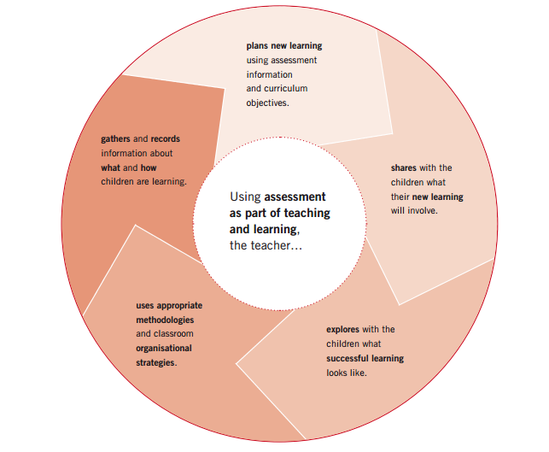

(NCCA, Assessment in the Primary School Curriculum – Guidelines for Schools. November 2007, p. 7).

Range of Assessment Methods used throughout the School
In Seir Kieran’s NS, we have a variety of strategies for assessment ranging from informal to formal as outlined below:

Both assessment for learning and assessment of learning will be used by teachers to make professional judgements about pupil achievement/progress. Deciding what to assess will be based on the curriculum objectives in each curriculum area/subject and on what the teacher intends to help the children to learn. Each teacher will use the most appropriate assessment method to measure the extent to which children have achieved these objectives. The range of assessment methods to be used throughout the school is outlined in this policy.

Assessment for each subject is mentioned in the relevant curriculum plans. Accordingly, the assessment policy will present a comprehensive overview of the strategies for assessment engaged in throughout the school.

Assessment for Learning
Assessment for learning is a way of informing and involving the learners themselves in the process of assessment. The following are the methods of assessment for learning in use in Seir Kieran’s NS:

- Teacher observation – individual /group /whole class with oral / written feedback
- Teacher-designed tasks and tests – weekly / end of term / end of topic / prescribed assignments with feedback
- Portfolios - pupils may assemble a portfolio of best / improved work
- Pupil Self-Assessment: The following are in use to enable the pupils to self-assess:
  - Concept maps
  - Completion of topic tests and whole class discussion with pupils allowing pupils the opportunity to self assess where they are at on specific learning outcomes or objectives within specific subject areas.
  - KWL / KWHL charts
  - Evaluation sheets
  - Checklists
  - Self-Evaluation Questions to facilitate reflection
  - Graphic Organisers – KWL charts and Concept maps as mentioned above. In addition younger classes may use thumbs up/ thumbs down and traffic light symbols.
  - Reflection; Representation; Reporting. Children think about what they have been learning. They then represent what they have learned (by – drawing, concept map, brainstorm, questions, map, paragraph etc.) Children then report on their learning – to teacher; class; group; parent; partner etc.

- Peer-Assessment - pair / group / whole class conferences. Children will use the above strategies or given criterion to peer assess. Necessary language will be modelled to better enable pupils to peer assess.

- Success and Improvement Strategy (also referred to as ‘two stars and a wish’) - involves children reflecting on their work and identifying two ‘best bits’/parts they like and one area where their work can be improved. Children can highlight the ‘best bits’ or put a star or smiley face beside it. Children also highlight one area where they could improve/do differently the next time. If possible, the children should have time to make the improvement. This process is particularly useful for children’s writing. Initially, teachers will model this process using exemplars. This strategy can be used orally in junior classes. This strategy may also be used when marking children’s work.

- Sharing the learning intention/objective and devising success criteria- WALT (We are learning to…) and WILF (What I’m looking for…) strategies. WALT sets out the learning intention / objective at the start of lessons and WILF establishes the criteria for success by specifying what the teacher is looking for from the children in an activity.

- We are learning to………………..(WALT)
- What I’m looking for ……………(WILF)
- We will know when we’ve achieved this because………….

The learning objective(s) and the success criteria may be displayed on a chart / whiteboard /post it etc.). The teacher /peer / self will evaluate the work by identifying successes and improvements against the criteria.

- Effective teacher questioning – teachers use higher order questioning to provoke fruitful discussion, ensure understanding and learning has taken place and to assess the level of the learning.

- Quality marking by teacher – occasional pieces of work marked thoroughly focusing on pointing out success and improvement rather than to mark every error in existence. On occasion ‘test’ marking will be undertaken whereby all aspects of the work will be marked e.g. a story where comments are made re. spelling, grammar, punctuation, handwriting and the overall quality of the work.

- Conferencing – teachers discuss with pupils their work and how they might improve it.

- Completed assignments by pupils - projects, work in copybooks, activities, work samples, homework etc.

- Standardised tests – analysed for errors and feedback may be provided to pupils

- Diagnostic tests – usually administered by the Special Education Teacher.

- Assessment by psychologist and/ or other outside agencies – Conclusions and information from the reports are acknowledged and recommendations followed where practicable

Assessment of Learning
The formal assessments conducted in the school are part of our assessment for learning procedures. They are conducted at specified times each year, recorded and reported to parents.

- Standardised tests
The following are the tests used in our school:
- Middle Infant Screening Test (MIST) – February/March each year used in Senior Infants
- Drumcondra Numeracy and Literacy Tests – May each year
- Micra T Level One – November each year (First Class)
- Drumcondra Primary Maths Test – May each year from 1st to 6th classes
- Drumcondra Primary Reading Test – May each year from 1st to 6th classes

The purpose of the standardised tests is to allow teachers to make placement and progress decisions based on assessment results and to develop appropriate interventions for certain children. The class teacher administers the standardised tests. In the event that a pupil is absent on the day of the test the Special Education Teacher will administer the test at a later date. Pupils may be excluded from the tests if in the view of the principal they have learning or physical disability which would prevent them from taking the test or newcomer pupils, where their level of English is such that attempting test would be inappropriate. Each child’s raw score, standard score, percentile rank, STEN and Reading age is recorded. The results are analysed at whole school level using the PDST tool and at individual class level, and the information gathered from the tests will be used to inform teaching and learning. The results are communicated to parents in an oral format at the Parent-Teacher Meeting in February and in a written format on the end of year report. The standardised score will be given to parents and an explanation/descriptor will be provided with each result. The results will help determine the allocation of SET hours in the school and the nature of the support provided (in-class or withdrawal). See SEN policy.

- Screening
Screening tests are used to facilitate the early identification of learning strengths / difficulties. Standardised test scores are used for screening pupils from 1st to 6th class. The NRIT is used for screening pupils in 1st Class. The NRIT is administered in late November and Standardised tests are administered in all class levels by the class teachers in May / June. Screening checklists and teacher observation are used to screen pupils for progression in special education. Test results are interpreted by the class teacher and SEN coordinator. Children under the 12th percentile on Standardised Tests are recommended for diagnostic testing and receive intervention. Consideration will also be given to the class teacher’s recommendation and/or results of class assessment tests. Priority for support in Literacy and Numeracy will be given to children who fall below the 12th percentile in the Drumcondra Standardised Tests throughout the school. Consideration will also be given to the class teacher’s recommendation and/or results of class assessment tests in Literacy and Numeracy. A letter is sent to a child’s parents / guardians to seek consent for completion of diagnostic testing.

- Diagnostic Assessment
A broad range of diagnostic tests are used to determine the appropriate special education teaching for the individual pupils who present with learning difficulties. This list can be found in Appendix 1 of this policy. The class teacher, in consultation with the SEN coordinator selects children for diagnostic testing. All parents are asked to sign a consent form before testing takes place. The Special Education Teacher administers the diagnostic tests and informs the class teacher and parents of the results. Following assessment the class teacher, the Special Education Teacher and the parents collaborate in formulating a plan to inform subsequent teaching and learning.

- English as an Additional Language (EAL) Testing
Any new pupils who come to the school and whose primary language is not English,will be tested as required. All EAL pupils are re-tested at the end of each instructional term using the Primary School Assessment Kit (PSAK).

- Special Education Testing
Pupils who fall below the 20th Percentile in the Standardised Screening Tests are eligible for Special Education support. Diagnostic testing is carried out by the relevant Support Teacher on these pupils in order to ascertain the pupils’ areas of strengths and weaknesses. Based on the results of the diagnostic testing, a learning programme is devised and delivered over the duration of an instructional term. The pupils may be re-tested in order to review progress. The diagnostic tests that may be used include NRIT Non reading intelligence test and Micra T / Sigma T.
Reviews of pupils’ support plans takes place at the end of each instructional term. See Appendix 1 for a list of all screening and diagnostic tests available.

- Teacher Designed Tests
Teachers may conduct End of Topic tests/ Weekly/ End of Term/Year tests in Numeracy, Literacy, Gaeilge and the other subjects. Teachers record pupil progress in these tests to establish benchmarks and ensure progression is monitored. These are then stored in Teacher’s assessment folders. Teachers can send home scored/corrected test sheets to parents for signing. This keeps parents informed about their child’s progress.

- Psychological Assessment
The principal/class teacher arrange consultations with psychologists (NEPS or other) if it is deemed necessary. Where psychological assessment is considered necessary he/she liaises with parents and standard NEPS consent forms are used. The Special Education Teacher is responsible for arranging assessments with specialists, psychologists, speech and language therapists or others. Specialist assessment reports inform all planning. Access to psychological reports is controlled by the Principal. Reports are stored in individual Pupil Special Education Files in a locked cabinet by the Principal. For further information see SEN policy.

Recording and Storing the Results of Assessments
- Pupil’s standardised test results are recorded in class grids (These are stored away in class folders) and on each individual end of year report. They are communicated to parents at Parent Teacher Meetings.
- Teachers have agreed terminology for reporting on children’s progress and achievement.
- Results of Standardised Tests are reported to the Board of Management and the DES (online) in June each year.
- Each teacher will have an Assessment Folder in which to store assessments carried out during the year.

Assessment Folder
Teacher designed tests and tasks may be stored in the class and are retained as a record of progress during the school year.

Success Criteria
- A range of informal and formal assessment modes are used to place assessment as an integral part of teaching and learning.
- Procedures run smoothly and efficiently because there is clarity about what is expected and who is responsible for different aspects.
- Transfer of information from class teacher to class teacher happens efficiently at the beginning/end of school year.

Roles and Responsibilities
All teachers are responsible for the implementation of the policy and are expected to use the information available to help pupils learn and progress.

Timetable for Review
- The operation of this policy will be reviewed again in 2024.
- The review will be initiated and coordinated by the teaching staff.

Communication
A copy of this policy is available to be viewed on our school website. This will be communicated to all parents via the December 2022 newsletter.

Ratification
This policy was ratified by the Board of Management at a meeting on the 21st of November 2022.

Signed: _______________________________________

Date: ____________
(Chairperson, Board of Management)

Appendix 1:

List of Screening/ Diagnostic methods in use in our school
- BAS (British Ability Scales)
- Aston Index: Infant Screening and Diagnostic
- NEPS Phonics Skills Check
- Two Peas Phonological Awareness Assessment
- Jolly Phonics Reading Assessment
- Test2R
- MIST (Middle Infant Screening Test)
- BIAP (Belfield Infant Assessment Profile)
- Phonological Awareness Assessment Battery
- Basic Number Screening Test
- Basic Number Diagnostic Test
- CAT4
- Drumcondra Primary Maths Test
- Drumcondra Primary English Test
- Drumcondra Primary Spelling Test
- Dyslexia Early Screening Test (4:6-6:5)
- The Dyslexia Screening Test (6:6 – 16:5)
- Neale Analysis of Reading Ability
- NNRIT (New Non-Reading Intelligence Test)
- NFER Nelson – Non Verbal
- PSAK – Primary School Assessment Kit for EAL
- Quest Early Screening and Diagnostic Test
- Schonell Reading Test
- YARC: York Assessment of Reading for Comprehension
- Ravens Crichton Vocabulary Scale

Appendix 2:

Sample of methods of Assessment Junior & Senior Infants
- Standardised Tests
- MIST (Term 2 Senior Infants)
- Jolly Phonics Reading Assessment
- Two Peas Phonological Awareness Assessment

- Teacher Designed Tasks and Tests
- Termly Tests
- Running Records
- Work Samples in Copybooks/ Art Folder
- Checklists
- Input from parents

- Teacher Observation
- Continuous monitoring of homework/ textbooks/ copybooks and parental feedback
- Use of mini – whiteboards (active student response)
- Work samples
- Active learning activities

- Questioning
- Teacher Questioning
- Peer Questioning

- Self-Assessment
- Smiley Faces
- KWL Charts
- Thumbs up and down
- 2 stars and a wish (Term 2 Seniors)
- My best bit

- Diagnostic Screening Tests (if required)
- Test2R
- BIAP (Term 3 Junior Infants)

Sample of methods of Assessment 1st/2nd/3rd Class

- Standardised Tests
- Drumcondra Primary Maths Test (DPMT)
- Drumcondra Primary Reading Test (DPRT)
- NRIT
- Teacher Designed Tasks and Tests
- Pre - Tests
- Summative Tests
- Termly Tests
- Running Records
- Project Work
- Work Samples in Copybooks/ Folders
- Portfolios
- Samples of the children’s work chosen by them (January onwards)
- Teacher Observation
- Continuous monitoring of homework/ textbooks/ copybooks and parental feedback
- Use of mini – whiteboards (active student response)
- Work samples
- Research Tasks and active learning activities
- Checklists
- Questioning
- Teacher Questioning (higher and lower order)
- Peer Questioning
- Self-Assessment
- Two Stars and a Wish
- Smiley Faces
- KWL Charts
- W.A.L.T. (sharing learning intention)
- W.I.L.F. (sharing success criteria)
- Peer assessment
- Two stars and a wish
- Feedback worksheets (Introduced in January)

- Diagnostic Screening Tests (if required)

Sample of methods of Assessment 4th/5th/6th Class
- Standardised Tests
- Drumcondra Primary Maths Test (DPMT)
- Drumcondra Primary Reading Test (DPRT)
- Drumcondra Primary Irish Test

- Teacher Designed Tasks and Tests
- Pre - Tests
- Summative Tests
- Termly Tests
- Running Records
- Project Work
- Work Samples in Copybooks/ Art Folder

- Teacher Observation
- Continuous monitoring of homework/ textbooks/ copybooks and parental feedback
- Use of mini – whiteboards (active student response)
- Work samples
- Research Tasks and active learning activities

- Questioning
- Teacher Questioning
- Peer Questioning

- Self-Assessment
- Two Stars and a Wish
- T.A.G
- Smiley Faces
- KWL Charts
- Rubrics
- Mind Maps / Concept Mapping
- Find and fix (error analysis)
- W.A.L.T. (sharing learning intention)
- W.I.L.F. (sharing success criteria)

- Diagnostic Screening Tests (if required)

