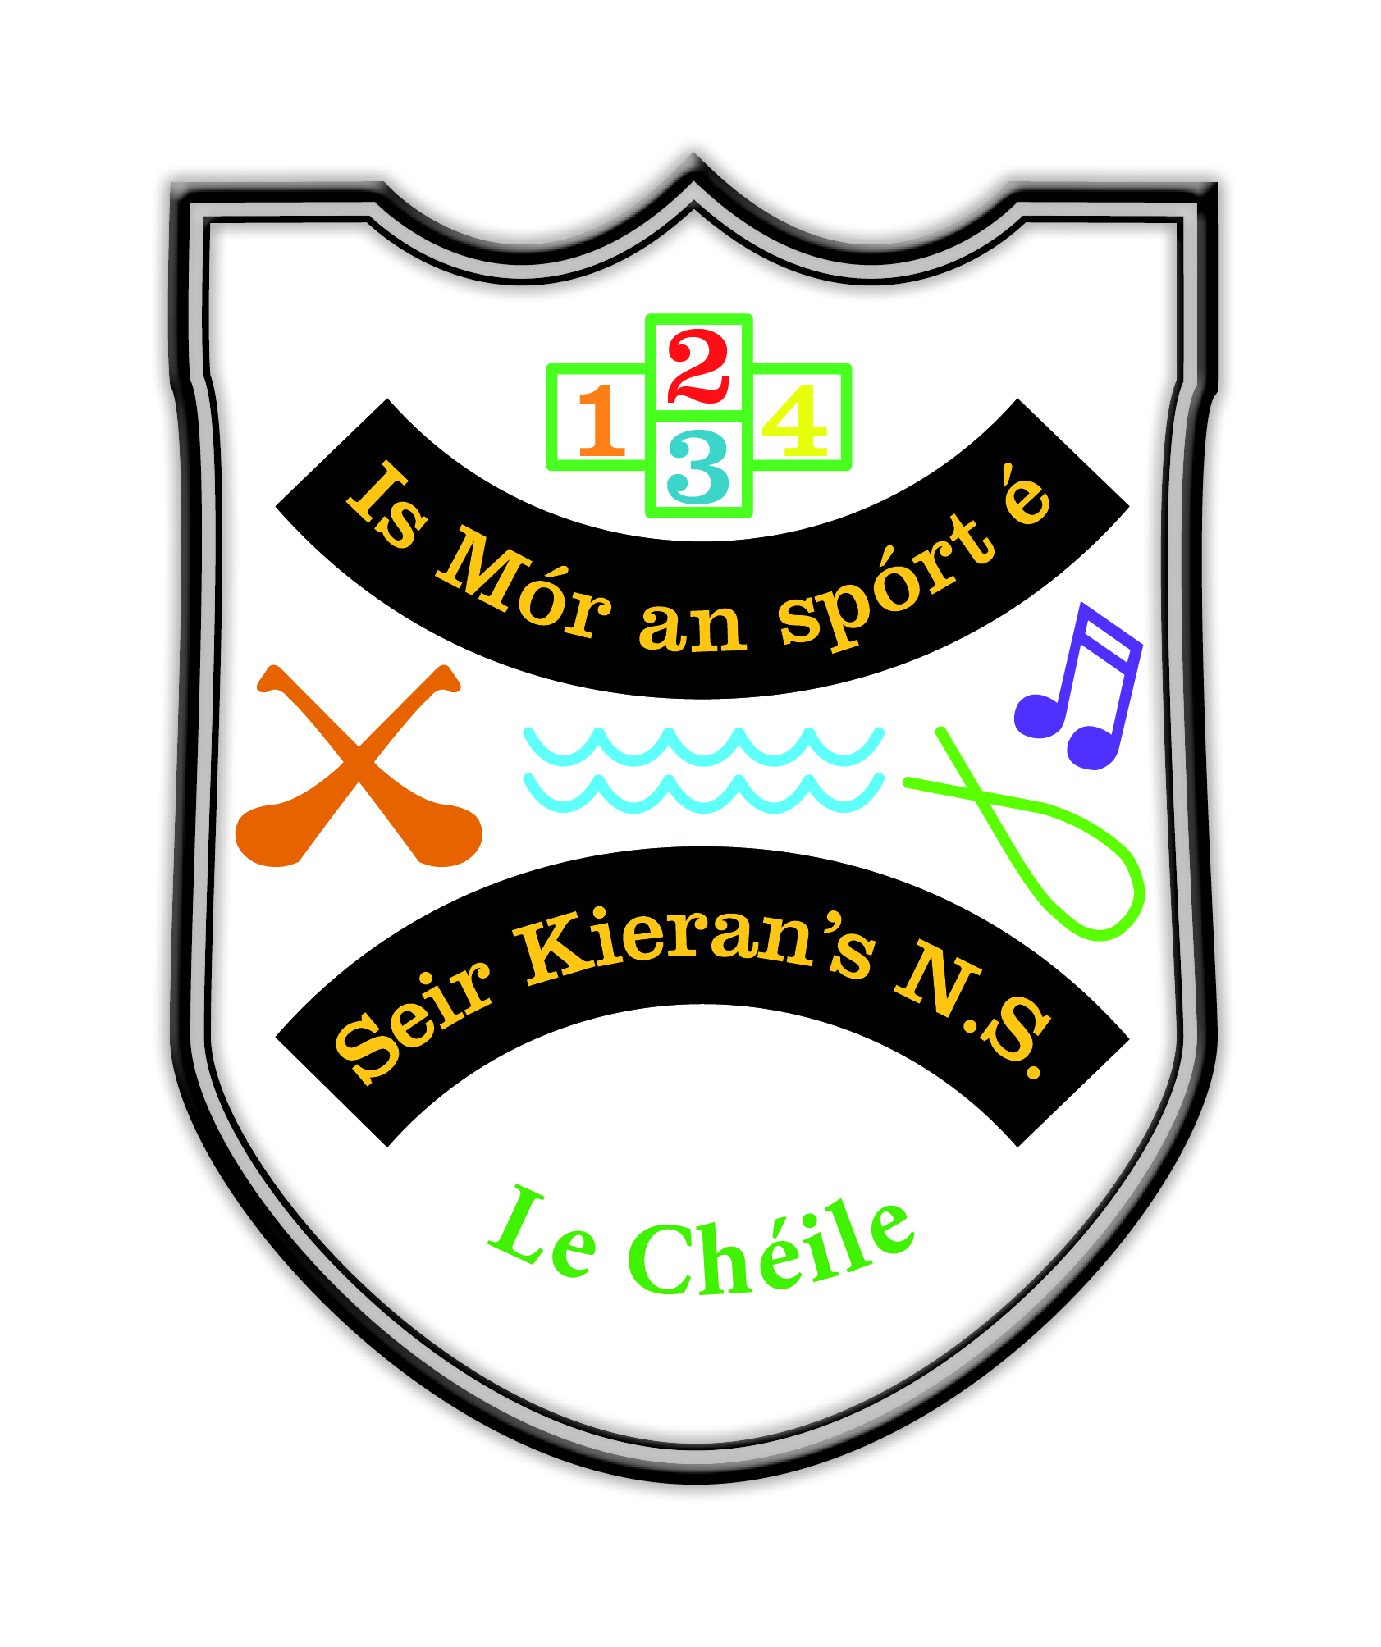

Seir Kieran’s NS Whole School Plan: English

Introductory Statement
This whole school plan for English was initially formulated in consultation with teaching staff in Seir Kieran’s N.S. in term 1 of the 2021/22 school year. Appendices as set out the end of the plan indicate specifics for each class grouping, therefore allowing for the plan to be used in a practical way to guide teachers in the planning and preparation for each class grouping.

Rationale
We prioritised this area of the curriculum because of the increasing importance placed on literacy because of the National Literacy and Numeracy Strategy 2011-2020. We also prioritised this curriculum area in light of the implementation of the new Primary Language Curriculum which came on stream in September 2016 and was revised in September 2019. Staff have engaged in training days based on the new Primary Language Curriculum and will continue to engage in these. We believe that a consistent, structured and intensive oral language and phonics programme will improve learning and teaching in all areas of the curriculum.

Vision
It is our vision to create a school where our pupils will communicate, read and write with and for each other, staff, parents/carers, visitors and the wider school community with clarity, confidence, fluency and respect.

Aims
We aim, through this plan, drawn up in accordance with the Primary Language Curriculum, to set out our approach to language teaching. This plan will form the basis for teachers’ long and short-term planning. It will also inform new teachers of the approaches and methodologies used in our school. We endorse the aims of the New Primary Language Curriculum, which are presented in 3 groups. The Primary Language Curriculum, and this whole-school plan, aims to support teachers to:

1. Children and their Lives
- enable children to build on prior knowledge and experience of language and language learning to enhance their language learning
- encourage children of different languages and cultures to be proud of and share their heritage
- recognise the wide variation in experience, ability and language style which children bring to language learning in school as a first step in enabling them to engage in relevant and meaningful communicative relationships.

2. Children’s communications and connections with others
- embrace children’s uniqueness by nurturing their appreciation of their home language, their understanding of language and diversity, and their ability to use different languages, gestures and tools to communicate with people in a variety of contexts and situations.
- encourage and enable children to communicate effectively in both the first and second language of the school and to communicate in their heritage language for a variety of purposes.
- enable children to fully engage with and enjoy a wide range of relevant and meaningful linguistic and communicative experiences with peers and adults.

3. Children’s language learning and development
- promote a positive disposition towards communication and language by fostering within children a lifelong interest in and a love of language learning for personal enjoyment and enrichment
- broaden children’s understanding of the world through a rich variety of language experiences and through fostering an awareness and appreciation of other languages and cultures in an enriching learning environment
- encourage children to engage personally with and think critically about a broad range of spoken, gesticulated, written and multimodal texts
- support children to develop their literacy skills and enable them to progress at their own learning pace in oral language, reading and writing
- nurture within children an awareness of language, allowing them to appreciate and understand the content and structure of languages and acquire a basic understanding of the history of languages and other cultures.

Curriculum Planning

Strands and Elements
The following table sets out the Strands and Elements of the Primary Language Curriculum:

Element 1: Communicating
Strand: | Learning Outcome:
Oral  Language | - Engagement, listening and attention (intentionality, verbal memory)  - Motivation and choice  - Social conventions and awareness of others (relevance, turn taking, extra- and paralinguistic skills)
Reading | - Engagement (intentionality)  - Motivation and choice (relevance)
Writing | - Engagement (intentionality)  - Motivation and choice (relevance, purpose, audience)

Element 2: Understanding
Strand: | Learning Outcome:
Oral  Language | - Sentence structure and grammar (syntax, morphology)  - Acquisition and use of oral vocabulary (semantics, verbal memory, articulation skills)  - Demonstration of understanding (semantics)
Reading | - Conventions of print (meaning and understanding of text/illustration)  - Phonological and phonemic awareness  - Phonics and word recognition (alphabetic principle, word identification strategies)  - Reading vocabulary (semantics)
Writing | - Conventions of print and sentence structure (syntax)  - Spelling  - Vocabulary (semantics)

Element 3: Exploring and using
Strand: | Learning Outcome:
Oral | 1. Requests and questions
Language | - Categorisation  - Retelling and elaborating (narrative text and response)  - Playful and creative use of language (aesthetic dimension of language)  - Information giving, explanation and justification (expository text)  - Description, prediction and reflection
Reading | - Purpose, genre and voice (awareness of author’s purpose)  - Comprehension (comprehension, text organisational structure and fix-up strategies)  - Response to author’s intent  - Fluency and self-correction (accuracy, fluency and meaning)
Writing | - Purpose, genre and voice (sense of voice, aesthetic dimension of text)  - Writing process (using processes, structures and language register)  - Response and author’s intent (author’s purpose and responding)  - Handwriting & Presentation (legibility)

Approaches in our School

1. Oral Language

Learning Outcomes for Oral Language
● See Page 22-23 of the Primary Language Curriculum
 | Element = Communicating
1. Engagement, Listening & Attention | 2. Motivation and Choice | 3. Social Conventions and awareness of others
 | Element = Understanding
4. Sentence Structure &  Grammar | 5. Vocabulary | 6. Demonstration of Understanding
 | Element = Exploring & Using
7. Requests, Questions & Interactions | 8. Categorisation | 9. Retelling & Elaboration
10. Playful and Creative Use of language | 11. Information Giving,  Explanation & Justification | 12. Description, Prediction & Reflection.

Whole School Strategies for Oral Language
- Assemblies:
Regular whole school/year group assemblies
Appropriate and respectful language is modelled
Good listening and appropriate responses are encouraged
Common social functions are taught
Positive non-verbal behaviour is encouraged

- Yard:
Using words to communicate and solve problems
Self-Maintaining Language
Model positive and respectful language

- School Related Functions:
Greetings as Gaeilge
Etiquette for children visiting classes

- Aistear:
Aistear activities daily in Junior and Senior Infants classes. We use a thematic approach for Aistear and ensure that an oral language/role play station is included in Aistear theme.

Timetable for Oral Language
▪ Aistear: 30 - 45 minutes 4 days per week
▪ Oral language lessons daily: discreet lessons/formal lessons/informal language use

Some Activities/Methodologies currently used for Oral Language
The following skills will be modelled and taught in our school at all class levels:
- Using words for common social functions in a polite and respectful manner (ongoing, daily)
- Communicating to meet personal needs (on-going, daily)
- Listening (rhymes, jingles, riddles, listening activities, bingo, news)
- Recalling (re-telling stories, class trips/visits, news)
- Naming (name, address, days, months, seasons, family members, things you need for/find in)
- Categorising and classifying (people, places, family, clothes, weather, animals, food, pets)
- Describing (colour, shape, feelings, characters)
- Denoting Position (orientation-left/right, relational/under/beside/behind/on/in)
- Sequencing (alphabet, days, months, seasons, times of day, sequencing words)
- Reasoning (relational words-because/but, problem solving-what shall I do? 20 questions, proverbs)
- Giving instructions and directions (how do we make a cup of tea/go to the shop?)
- Reporting (reporting back from a group activity or project)
- Speaking out clearly (on going, daily)
- Predicting (hear part of a story, what do you think will happen next?
picture sequences)
- Projecting/empathising (picture/story, how do you think they are feeling? How would you feel if I?)
- Imagining (a new planet, a newly discovered species of animal)
- Questioning (20 questions, the Yes/No game show)
- Interpreting and using appropriate non-verbal language
- Taking turns in speaking and listening (circle-time, news time)
- Showing tolerance for views of others (circle-time, debating)
- Think Talk time (thinking and talking about questions of a philosophical nature to develop critical-thinking)

Resources/Methodologies for Oral Language
● See each class level below

Teacher’s planning for Oral Language
- English oral language and Gaeilge ó bhéal are integrated thematically through Aistear, through teaching topics at the same time, discussing language based on stories
- New vocabulary is displayed in the classrooms.
- Key vocabulary for pupils is identified for all subject areas.

2. Reading

Learning Outcomes for Reading
● See Page 26 of the Primary Language Curriculum
Element = Communicating
1. Engagement |  | 2. Motivation and Choice
Element = Understanding
3. Conventions of Print & Sentence Structure | 4 Phonological & Phonemic Awareness | 5. Phonics, Word  Recognition & Word Study | 6. Vocabulary
Element = Exploring & Using
7. Purpose, Genre & Voice | 8. Response & Author’s Intent | 9. Comprehension | 10. Fluency & Self Correction

Aims for Reading
In the area of reading development, we aim to:
- promote positive attitudes and develop the appreciation of reading
- develop print awareness, an understanding of the purpose of print, and a control over the different ways meaning is derived from print
- develop a range of reading skills and abilities that would include phonemic awareness, word identification strategies and a growing sight vocabulary
- develop an appropriate range of comprehension strategies to help interpret text beyond the literal level (prediction, inference, etc.)
- develop an awareness of the richness and diversity of reading material reading from a variety of texts of gradually increasing complexity
- engage in and enjoy sustained silent reading
- enhance emotional and imaginative development through reading
- develop cognitive ability and the capacity to clarify thinking through reading Use the school library to increase fluency and interest in books.
- Use explicit instruction of reading skills and strategies to enable at-risk children to participate more fully in literary experiences.

Whole School Initiatives for Reading
- World Book Day
- Daily D.E.A.R. time
- Paired/Buddy Reading
- Study of Authors and Visiting Authors
- Visits from and to Birr Library
- Team Teaching focus on Reading Skills
- Primary Planet and Newsflash purchased by Board of Management/Parents Association.

Resources/Methodologies for Reading
● See each class level below

Supplementary Resources for Reading
- Big Books
- School Library
- Birr Library
- Poetry & Rhyme Books
- Story Books
- Fairy Tales
- Books of Myths and Legends
- Scrapbooks
- Posters
- CDs/Interactive whiteboard resources
- Games
- Activities

School Library
We are in the process of reorganising our school library so as to give children access to a wide range of reading material. Due to the accommodation of an ASD class, we are currently relocating our library and we are taking the opportunity to revise what it is contained within it. The objective is to have this up and running fully by January 2023.

Rhymes
Children in Infant classes will learn one Nursery Rhyme per week - See Nursery Rhyme Scheme (Infant level)

Poetry
Children from First to Sixth class will study at least one poem per month. A poem will also be used as a stimulus for discussion and integrated with Art/SESE/Ethical Ed - Children are provided with frequent opportunities to experience poetry and are encouraged to respond to it in different ways. Children are given the opportunity to display and read poetry.

Story
The children will explore the following types of story between Infants and Second class Fairy Tales, Fables, Myths and Legends. Picture books should not only be used merely as storybooks but as a meaningful context for teaching sight-words, phonics, fluency, comprehension, concepts of print, phonological awareness and critical thinking. Extracts from novels and novels will be used from First to Sixth class and will be integrated with SESE where possible.

Phonological Awareness & Phonics
Phonological Awareness and Phonics is an integral part of the acquisition of the English language and a huge emphasis is placed on its importance in the early school years.

- Rhyming Awareness
- Word Awareness
- Syllabic Awareness
- Phonemic Awareness - Isolation of initial/final/medial sounds
- Blending
- Segmenting
- Manipulation
- Look and Say

Alphabet
Reciting the alphabet will be taught in Junior and Senior Infants. Children will be asked to say the alphabet starting and stopping at different intervals to promote familiarity. Children will be encouraged to state the name and the sound together using the Sounds Like Phonics A&B. Awareness of vowels will be taught from Junior Infants.

Sight Words Sight words are taught as Tricky Words in Junior and Senior Infants as part of the Jolly Phonics programme. Reading material is used to teach Sight words from First Class.
Reading Comprehension
Comprehension Strategies as set out in the new Oral Language Curriculum are taught to all classes.

Writing

Learning Outcomes for Writing
● See Page 30 of the Primary Language Curriculum
Element = Communicating
1. Engagement, Listening & Attention |  |  | 2. Motivation and Choice
Element = Understanding
3. Conventions of Print & Sentence Structure |  | 4. Spelling and Word Study |  | 5. Vocabulary
Element = Exploring & Using
6. Purpose, Genre & Voice | 7. Writing Process & Creating Text |  | 8. Response & Author’s Intent |  | 9. Handwriting & Presentation

Aims for Writing
In the area of writing development, we aim to:
★develop competent and confident writers in all writing genres
★develop print awareness and an understanding of the purpose and conventions of print
★promote a growing sight vocabulary
★utilise the various comprehension strategies
★write for different purposes and different audiences
★learn to edit and refine writing and develop a sense of appropriate presentation
★develop a personal style of writing and learn to distinguish and use appropriate levels of formality
★share writing experiences with others
★use computer technology in learning to write – use of Google Docs and Google Classroom to publish pupils’ writing

The 7 Steps to Teaching a Genre:
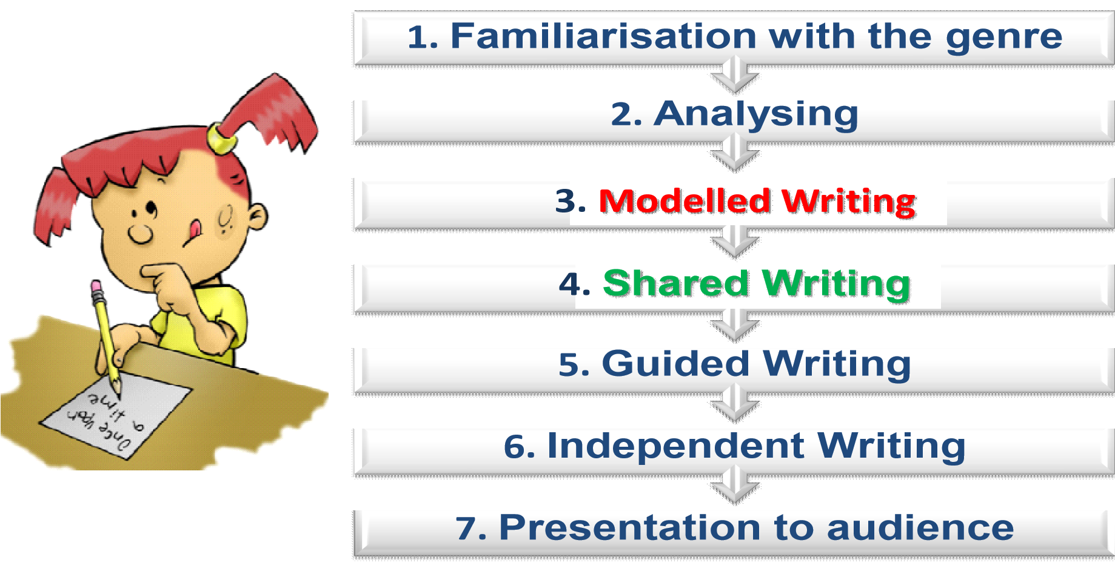

Spelling
We recognise that, as a whole school, a multi-dimensional approach to spelling is essential. Every class has varying levels of spelling ability and the pupils are differentiated and assessed accordingly. Some children struggle to move from the phonetic to transitionary stage of spelling.

Objectives for Spelling
- Equip all pupils with strong phonological awareness skills incorporating awareness of syllables, rhyme and phonemes in words
- Spelling must be taught
- Spelling must be fun
- Realisation that not all spelling is phonetically based
- Spelling activities should be written
- Spelling lessons should be daily; short and snappy
- Spelling strategies are taught to all children especially those who experience difficulty
- Self-checking is continuously encouraged to foster a more independent approach
- Spelling must never be a barrier to children’s writing as it is vital not to dampen a child’s enthusiasm to write by always insisting on accurate spelling
- Children are encouraged to take risks and attempt unknown words
- Provide opportunities for children to ‘problem-solve’ the rules themselves
- Children begin spelling informally in Senior Infants through exposure to phonics.
- Formalised spelling is introduced in First Class and continues throughout the remainder of the pupils’ years in the school.

Source of Spellings
- Reading material
- Phonics Scheme
- Prim Ed. Spellings Programme
- Children’s Writing Needs
- Extension Work: Themed Spelling
- Dictionary Book/Folder

Our Approach to the Teaching and Learning of Spelling
- As spelling is visual, learning to spell cannot follow a completely phonics based programme. The pattern in words must be visual so that words that look alike are grouped together although they may not sound alike. e.g. caught, daughter, taught
- Our focus is on letter patterns instead of just learning mat/hat, but/cut, we focus on ‘at’ patterns (letter strings), and therefore include ate, what, etc. It is important that we teach words which look the same irrespective of their sound, e.g. come, some, women…
- Children are taught to look at words, see words within words and compare letter strings regardless of sound
- Spelling is taught with emphasis on the type of spelling errors rather than the number of errors
- The use of mnemonics and other strategies are encouraged to help children who struggle with spelling
- Look, Say, Cover, Write, Check Methodology (Look, Write & Check are all visual which emphasises the importance to spelling being a visual endeavour)
- Using Sound Letter Relationships
- Using Pattern
- Continuation from class to class
- Linking with onset and rime
- Print Rich Environment
- Class Based Incentives

Assessing Spelling
The children are encouraged to improve their spelling in writing rather than an over emphasis on ‘the Friday spelling test’. Children may perform well in such spellings tests but unless there is an improvement in the child’s writing, it is pointless. Children are assessed by way of a spelling/dictation/cloze test every week. This is combined with regular assessment of the child’s independent writing.

Correcting Spelling
- Teachers will correct the spelling/dictation tests and return them to the children. In the case of the senior classes, children correct their own work under the direction of the teacher, therefore allowing them to actively assess where they made mistakes and as a group we actively discuss such common mistakes.
- Teachers are encouraged to avoid marking every spelling wrong, instead to underline the part of the word that is incorrect.
- We do not make public any child’s results
- Teachers are encouraged to avoid asking children to write out corrections several times

Spelling and the Learning Support/Resource Teacher
Arrangements may be made under the direction of the class teacher.

Parental Involvement and Spelling
Parents are encouraged to ensure that their children learn their spellings each night as part of their homework using a multisensory approach. This can be done by using the Look, Say, Cover, Write, Check Method and by practising sentence dictation.

Grammar & Punctuation
Grammar and punctuation are introduced formally from first class through the programme which is being used with the class grouping during that particular year.

Handwriting/Penmanship
As per the primary language curriculum, children will be encouraged to write legibly and fluently in a chosen script using a personal style, ensuring correct formation of lower and upper-case letters. Throughout the school there is an emphasis on penmanship.
In Junior Infants, the pupils begin by learning one lower-case letter per week. As their fine-motor skills develop, the pupils continue learning 2 letters per week until the formation of all letters is taught. In Senior Infants they will learn how to form upper case letters.
The importance of precision and presentation is constantly reiterated and encouraged in copies, worksheets, free writing and otherwise. Children will present copies neatly always using a date, title and ruling margins where necessary. An emphasis will be placed on this from second class up.

Our Approach to Handwriting:
- The best way to ensure good handwriting is to learn it correctly from the beginning
- Good penmanship also improves spelling since letter strings are connected when the child is writing a word.
- Good posture, pencil-grip and how the children form their letters are explicitly taught
- Pre-writing patterns are taught before separate letter formations at infant level
- Children are encouraged to practise common letter strings after learning how to form an isolated letter, e.g. ‘a’ – ate, at, eat, etc…

Approach Used to Introduce Letters
- Handwriting Copy
- Air pencil
- Tracing: on table, on each other’s backs
- Márla
- Sandpaper letters
- Large Letter in Crayon
- In Sand
- In paint bags

Pencil Grip & Position of body
- Tripod Grip with ‘frog legs’
- Helper hand to hold page in place

Provisions for Left Handed Children
- Sit at the desk on the left hand side
- Letter writing worksheets designed for children who are left handed in infants when they are practising handwriting if required E.g. writing the example of the letter on the right hand side of the page

Timetable for Penmanship
- Junior Infants and Senior Infants: 15 minutes/day
- First – Second class: 30 minutes/week

Correcting Handwriting
- If a mistake is made when writing in pencil it is erased with an eraser
- If a mistake is made when writing in ink children are instructed to put brackets around the offending word and a line through it. (---------).

Parental Awareness of Handwriting
- Guidelines/instruction for parents will be provided at the teacher’s discretion

Creative Writing
Children begin Creative Writing informally in the infant classes. This is stimulated and developed in many ways such as through Aistear and through the use of free drawing (Infant Classes) and free writing copies. Creative Writing is introduced formally in First Class and continues throughout the remainder of the children’s years in the school.

Selecting Topics for Creative Writing
Sources of topics for children’s writing include:
- Print-Rich Environment
- First Steps Writing- Narrative Genre
- Thematic Approach
- Personal Concerns
- Life at home and in school
- Stories
- Social Needs
- Personal Reading
- Poetry
- Drama and Aistear
- Everyday personal experiences
- Use of home language

Strategies for Planning Creative Writing
- First Steps Writing- Narrative Genre strategies and ideas
- Oral Discussion: Whole Class, Teacher/Pupil, Pupil/Pupil
- Brainstorming
- Webbing
- Story Board
- Story Plans
- Story Templates
- Poetry/Drama/Story as stimulus

Whole School Approaches to Writing and Drafting
- Planning, Drafting, Editing, Re-drafting Method through the medium of First Steps from First Class
- Encouraging Self Correction and Self Checking

Correcting Creative Writing
Constructive comments are used by teachers when correcting the children’s work.

Whole School Approaches to Valuing Creative Writing
- Displays
- Constructive and precise comments when possible
- Work included in anthologies
- Team Teaching with a focus on the Narrative Genre for creative writing

Assessment and Record Keeping
- Standardised testing: BIAP, Drumcondra Test of Early Literacy, Drumcondra Reading Tests etc.
- Teachers will hear children reading formally at least once a week.
- Spelling/Cloze tests
- Teacher checklists
- Teacher observation
- Teacher designed tasks
- Assessment copies/folders
- Projects
- Diagnostic tests

Children with Different Needs and ‘Le Chéile’.
English activities will be differentiated in order to meet the needs of the children in a particular class. Children with special educational needs will receive support from our Special Education Teachers. We promote an active learning environment, with children working in groups at their level, where the class teacher is responsible for the learning in the classroom and is assisted by the SET teacher. Team teaching and Station teaching blocks are arranged where possible.

Where a teacher recognises that a child displays a particular ability in English, this will be communicated to the parents, so that the child may have opportunity to take out of school lessons, circumstances permitting. Teachers will encourage such children to read and write for their classmates, so that the other children will have opportunities to listen and respond.

Our ‘Le Chéile’ class supports children with ASD to achieve their potential in the core skills of oral language, reading and writing. Each pupil has a yearly Individual Eduation Plan containing collaboratively written targets to meet identified needs. These targets encompass the elements of language learning within the strands of the Primary Language Curriculum. Suitable and individualised resources are then utilised to meet the learning needs of pupils.
Learning and development within the language curriculum is assessed and mapped using the stages within the Learning Outcomes. Developmentally-appropriate and high interest topics are central when planning to support children’s language learning. Differentiation plays an important role in scaffolding each child’s progression through the stages of the Learning Outcomes. Each pupil's progress is reviewed regularly through a variety of assessment measures.
The following are a range of programmes and resources that may be used to meet individualised targets and the Learning Outcomes within the Primary Language Curriculum. Alternative and additional programmes may be implemented as resources and approaches are child-centred and based on the individual needs of the child.
- PECS
- LÁMH
- DIR Floortime
- Social Stories
- Attention Autism
- TEACCH
- We Thinkers! Social Explorers Programme
- Talkabout for Children
- Tasks Galore books
- Zones of Regulation programme
- Sounds Like Phonics Programme/Jolly Phonics
- Building Bridges of Understanding Programme
- My Spelling Workbooks and online resources
- Decodable readers
- Reading and writing workshops
- Literacy circles
- SNIP Programme
- Handwriting Without Tears Programme
- Aistear

Equality of Participation and Access
Equal opportunities will be given to all children regardless of gender, ethnic background, socio-economic status across all strands and activities.

Homework
Teachers can assign English homework at their discretion in accordance with the guidelines of the homework policy and the Department of Education. As a core subject, English homework should be assigned daily. Parents/carers are regularly reminded of the importance of oral language and reading homework, as well as written work.

Organisational Planning
The teaching of English will be conducted in line with the time allocation as set out by the DES and NCCA (ref: Circular 0056/2011), as follows:
Class Level: | Time Allocation for Language 1 (i.e. English):
Junior and Senior Infants | 4 hours per week
First – Sixth Class | 5 hours per week
★ Discretionary time may also be used for the teaching and learning of English

Resources and ICT
As a school which is fully committed to engaging with all aspects of the new English Language Curriculum, we endeavour to build on and develop the resources available for teaching and learning . Teachers will be encouraged to maximise resources available to them.

ICT will be used in classroom and support settings to further support the teaching and learning of English in the form of Interactive Whiteboards, iPads, online programmes etc.

The BOM and PA are fully committed to supporting our school in acquiring resources which we as a school identify as valuable in enhancing the teaching and learning of English in our school.

Individual Teachers Planning and Reporting
Class Teachers’ Planning:
Individual teachers will plan their yearly English programme specifically for their own class, while at the same time ensuring that their plan coordinates with and is reflective of this overall school plan. This should ensure clear progression as children move from class to class. Teachers at each class level will collaborate on content and methodology for English from this whole school plan and it will be monitored and assessed on an ongoing basis.

Teachers are expected to complete yearly (or termly) plans for the teaching of English in their classes and are responsible for the implementation of such. Learning outcomes directly from the Primary Language Curriculum are included in each teachers’ long term scheme and short term planning.

The Cúntas Míosúil is linked to the teacher’s short term planning and reflects what has been covered in the teaching and learning of English each month

Staff development
Staff needs will be assessed and the local Education Centre will be requested to provide suitable ongoing training as the need arises. The staff will also avail of training as provided by the Department of Education and Skills, particularly in relation to further training days for the implementation of the Primary Language Curriculum.

Parental Involvement/Community Links
Parents/carers have a crucial role to play in their children’s language development. Talking to adults, hearing them talk, hearing stories read and told and being encouraged to read all have an influence on children’s language development that supports and compliments the school experience. Parents are informed of this at every available opportunity, for example , at Parent Teacher Meetings and at addresses to the PA.

Success Criteria
Means of assessing this plan are as follows:
- Teacher/parent/pupil/community feedback
- Children’s feedback regarding their learning
- Suggestions and reports of DES Inspectorate
- Monthly records of teaching and learning
The success of this plan will be measured by teacher observation of pupil enjoyment and participation in oral language, reading and writing activities. The success of the plan will also be measured by the achievement of pupils in standardised tests. Feedback and reflection will be used as an informal method of measuring the success of this whole school plan.

Implementation and Review
- Roles and Responsibilities
The plan will be implemented by all members of the teaching staff. The principal will play the key role in the initial stages in overseeing the plan’s implementation. Responsibility for overseeing the plan in the future maybe assigned to a post holder.

- Timeframe
This plan will be reviewed in Term 1 2023/2024.

Ratification and Communication
The attention of all newly appointed staff will be drawn to this whole-school English plan upon their appointment to the school by the Principal. This policy will be published on the school website, upon its development, and a copy of it will be provided to the Parent Teacher Association, when established. A copy of this policy will be made available to the Department of Education and Skills and the Patron, if requested. Hard copies of this, and all school policies, are available at the school upon request.

Signed: _______________________
(Chairperson, BOM)

Signed:_________________________
(Principal)
Date: 23/05/2022
Date of next review: Term 1 2023/2024

